
No: WD-0003-20XX Ver: V1.0

Verification Methods and Technical Requirements for Human Finite Element Models in Virtual Crash Assessment

Intelligent New Energy Vehicle All Domains Safety Association


※Drving Safety※
Technical committee
Drving Safety

Published：20XX-XX-XX

Copyright © Intelligent New Energy Vehicle All Domains Safety Association（IADS）

Introduction

- Intelligent New Energy Vehicle All Domains Safety Association (referred to as IADS) is an international non-profit group standard organization established in Hong Kong in 2024. The vision of the organization is: "zero" casualties of life, "zero" dangers of health, "zero" loss of property, and "zero" disclosure of privacy. The mission of IADS is: to build an international platform for collaborative innovation and cooperation; to promote the establishment of all-domains safety standards and international application; to promote high-quality products and to protect the safety of drivers and passengers.
- IADS will regularly organize international exchange conferences, international standard development, standard promotion and other industry activities to support the efficient development of the automotive industry.
- This standard is published by IADS.
- The purpose of IADS standard is to serve the development of automobile industry, and the standard itself does not constitute mandatory. We encourage standard participants to put the IADS standard into use and provide them with valuable suggestions.
- All global automotive entities are welcome to participate in the formulation of IADS standards. If you have any questions about the standards, please contact the Secretariat of the Association.（Email：iadsafe@outlook.com）
Copyright

All rights reserved by IADS. Unless otherwise specified, this publication and its sections shall not be reproduced, republished, or used in any other form or by any means, including electronically, in photocopies, or posted on the Internet and Intranet, without permission. Licenses for use and distribution must be authorized by IADS. For further information, please contact the IADS Copyright Office：

Tel: +852 8483 0334 Email: iadsafe@outlook.com Website: www.iadsafe.org.
Patent

The IADS standard was developed in accordance with the IADS patent policy.
Please note that implementation of this standard may require the use of subject matter covered by patent rights. By issuing this standard, IADS does not take any position on the existence or validity of any patent rights associated with it. If the patent holder or patent applicant has submitted a warranty statement by accepting the warranty letter, it will be listed on the IADS website at www.iadsafe.org. The warranty letter may indicate whether the author is willing or unwilling to grant a licence of the patent right without compensation or at a reasonable compensation rate, on reasonable terms and conditions that are manifestly not likely to result in any unfair discrimination against applicants who wish to obtain such a licence.
If a warranty has not been received, there may be an essential patent claim. IADS is not responsible for determining the essential patent requirements that may require a license, investigating the legal validity or scope of the patent requirements, or determining whether any license terms or conditions relating to the filing of the warranty, if any, or any license agreement are reasonable or non-discriminatory. Users of this standard are expressly advised that it is their sole responsibility to determine the validity of any patent rights and the risk of infringement of those rights. More information can be obtained from the IADS Standards Association.
Participants

Chair ------------------------------------------------------------------------------------- Yu Liu
Secretary -----------------------------------------------------------------------------Huida Zhang
Members

China Automotive Engineering Research Institute Co., Ltd.--------------------------------Yu Liu, Guojie Wang, Huida Zhang, Xiaofan Wu, Linwei zhang, Kexin Huang, Qingzhu Luo, Saifei Song, Jie Chen,Jiapeng Li
Hunan University-----------------------------------Zhonghao Bai, Guanjun Zhang, Qiang Wang
Toyota Motor (China) Investment Co., Ltd.--------------- ---------------------------------Sen Lin
Global Human Body Models Consortium--------------------------------------------Chin-Hsu Lin
Autoliv (Shanghai) Automotive Safety System R&D Co., Ltd.--------- Feixia Liu，Huangqing Zhu
BMW China Automotive Trading Ltd. -------------------------------------------------Chun Wang
Chongqing changan automobile co. ltd--------------------------------------------------Yong Liu
Faurecia (China) Holding Co., Ltd. ---------------------------------------------------------Jing Cui

Thanks

OxSenses Co., Ltd.------------------------------------------------------------------------------XXX
Balloters

OxSenses Co., Ltd.------------------------------------------------------------------------------XXX

Verification Methods and Technical Requirements for Human Finite Element Models in Virtual Crash Assessment

- Overview
This group standard establishes comprehensive verification methods and technical requirements for adult occupant human finite element (FE) models utilized in virtual assessments. Its primary objective is to guarantee the accuracy and reliability of these models, which are indispensable in fields such as automotive safety research.
The document opens by citing relevant normative references, including national standards on units, measurement, and mechanical properties, thereby laying a solid foundation for the subsequent regulations. It also provides precise definitions for key terminology—such as the Frankfurt Plane, Ellipse Score, and various mechanical parameters—to ensure a unified understanding across the industry.
Regarding software and model specifications, the standard recommends Altair HyperMesh, LS-DYNA, LS-Prepost, and Altair HyperGraph for model construction, simulation, and post-processing, while allowing for the use of other equivalent software. To ensure consistency in data interpretation, all models must strictly adhere to the International System of Units (SI) and adopt a standardized coordinate system.
For specific anatomical regions, including the head, thorax, abdomen, and pelvis, the standard details rigorous requirements regarding metrology, element quality, sensor placement, validation scenarios, boundary conditions, output metrics, and verification criteria.
The appendices further specify the setup methods and locations for intrinsic sensors, alongside the necessary boundary conditions for human model validation scenarios. Overall, this standard provides a systematic and robust framework for validating the Chinese 50th percentile male occupant FE model, significantly advancing the development and application of high-precision human body models across relevant industries.
- Scope
This document specifies the verification methods and technical requirements for occupant human finite element (FE) models used in virtual assessments. It establishes specifications for model components, validation conditions, mesh quality, boundary conditions, and result analysis for both segment-specific and whole-body models.
This document is applicable to the verification of human finite element models across various anthropometries. Using the Chinese 50th percentile male as a reference, models with other anthropometric specifications may adopt this document for implementation.
- Normative references
The contents of the following documents constitute essential clauses of this document through normative references in the text. For the referenced documents with dates specified, only the versions corresponding to those dates apply to this document; for the referenced documents without dates specified, their latest versions (including all amendment sheets) apply to this document.
GB 3100 - 1993 The International System of Units and Its Application.
GB/T 3101 - 1993 General Principles Concerning Quantities, Units and Symbols.
GB/T 5703 - 2023 Basic Items of Anthropometry for Technical Design.
GB/T 10623 - 2008 Terminology for Metallic Mechanical Properties Tests.
GB/T 10000-2023 Human Dimensions of Chinese Adults.
Technical Bulletin CP 550 v1.1 Qualification Procedure for Human Body Models.
- Definitions, acronyms and abbreviations
  - Definition
4.1.1 Frankfurt Plane
When the median sagittal plane of the head remains vertical, the standard horizontal plane formed by the two tragion points and the right suborbital point.
Note: This plane is also known as the eye - ear plane.
4.1.2 Ellipse Score
The Ellipse Score evaluates how well the simulation data aligns with the characteristic average response by determining whether each simulation point falls within statistical confidence regions defined by ellipses. A point inside the 1 SD ellipse receives a score of 1, a point outside the 2 SD ellipse receives a score of 0, and points between these boundaries are assigned a linearly scaled score (according to CP550).
4.1.3 DALW
The Dynamic Arc-Length Warping (DALW) Score refines the assessment by optimizing the alignment of simulation and test data before applying the same ellipse-based scoring method. This process dynamically adjusts the arc-length mapping of the simulation data to better match the characteristic average, ensuring that variations in response trajectories are accounted for. The methodology follows a similar approach to the alignment process used for the magnitude score in ISO 18571, where dynamic time warping is applied to enhance curve comparisons in biofidelity evaluations. The final score reflects the best
achievable fit while preserving the underlying structure of the data (according to CP550).
  - Acronyms and abbreviations
4.2.1 BMI
BMI (Body Mass Index) is a widely used anthropometric parameter calculated as a person's weight divided by the square of their height (kg/m²).
4.2.2 SHS
Sitting Height to Stature Ratio (SHS) is a critical anthropometric parameter for defining the geometry of the human body model.
4.2.3 ASIS
ASIS (Anterior Superior Iliac Spine). It is the bony projection located at the front (anterior) and upper (superior) part of the iliac crest. It serves as a crucial anatomical landmark for taking pelvic measurements and defining coordinate systems in biomechanics.
4.2.4 AIIS
AIIS (Anterior Inferior Iliac Spine). It is another bony prominence located on the front of the ilium, positioned just below the ASIS. It acts as the attachment point for the rectus femoris muscle and plays an important role in hip joint kinematics.
4.2.5 PSIS
PSIS (Posterior Superior Iliac Spine). It is the bony projection found at the back (posterior) and upper (superior) part of the ilium. Along with the ASIS, it is a key landmark used to determine the orientation of the pelvis, such as defining the Frankfurt Plane or the pelvic tilt angle.
- Technical
  - General Provisions
5.1.1 Software Configuration
This document can use Altair HyperMesh software to build segment verification models, LS - DYNA for model simulation calculations, and LS - Prepost and Altair HyperGraph software to extract and analyze simulation results. In actual use, software other than these can also be adopted.
5.1.2 Model Unit System
The verification model established based on the finite - element model of human body segments adopts the International System of Units. In this document, the units of length (mm), time (ms), mass (kg), force (kN), stress (GPa), and energy (J) are used.
  - General specifications for human body models
5.2.1 Anthropometric specifications
The fundamental anthropometric parameters of the human body model shall comply with the 50th percentile male anthropometry specified in the Chinese National Standard GB/T 10000-2023 (within a ±5% tolerance).：
Body weight：68.00±3.40 kg；
Stature：168.60±8.43 cm；
BMI：23.75±1.19 kg/m2；
SHS：0.544±0.027。
5.2.2 Structural requirements for the human body model
The model shall incorporate the major skeletal structures and key soft tissue structures of the human body, including at least the following: the skull, spine (cervical C1-C7, thoracic T1-T12, lumbar L1-L5, and sacrum), pelvis, sternum, ribs, scapulae, clavicles, long bones of the limbs, knee ligaments, as well as the bones of the hands and feet.
5.2.3 Quality requirements for human body model
There are no mandatory requirements for mesh quality, but a summary of the model mesh quality (Table 1) shall be submitted.
Table 1 Mesh quality
Quality Metric | Item | Max/Min Value / Number of Elements
Number of Shell Elements | #
Number of Soild Elements | #
Jacobian - Shell | Minimum Value
Jacobian - Shell | < 0.3
Jacobian - Shell | < 0.5
Jacobian - Shell | < 0.6
Jacobian - Solid | Minimum Value
Jacobian - Solid | < 0.3
Jacobian - Solid | < 0.5
Jacobian - Solid | < 0.6
Aspect Ratio - Shells | Maximum Value
Aspect Ratio - Shells | >6
Aspect Ratio - Shells | >8
Aspect Ratio - Shells | >10
Aspect Ratio - Solids | Maximum Value
Aspect Ratio - Solids | >6
Aspect Ratio - Solids | >8
Aspect Ratio - Solids | >10
Warpage - Shell | Maximum Value
Warpage - Shell | >5
Warpage - Shell | >7.5
Warpage - Shell | > 10
Warpage - Shell | > 15
Warpage - Shell | > 30
Warpage - Solids | Maximum Value
Warpage - Solids | >5
Warpage - Solids | >7.5
Warpage - Solids | > 10
Warpage - Solids | > 15
Warpage - Solids | > 30
Time Step Size | Time Step of Worst Element
Time Step Size | Minimum Time Step Defined by Control Cards
Mass | Mass Scaling for Initial Time Step
Mass | Total Model Mass
  - Sensor Configuration
The HBM shall be equipped with the sensors listed in Table 2. Detailed locations and setup instructions for selected sensors are provided in Appendix A.
Table 2 Summary of HBM Sensors
Name | Body Region | Specific Location | Output Type | Virtual Assessment Output | Applicable Use Cases
Head_Local/Global | Head | Head Center of Gravity | NODOUT | ✔ | ✔
C1 | Neck | First Cervical Vertebra | SECFORC | ✔
C7 | Neck | Seventh Cervical Vertebra | SECFORC | ✔
T1_Local/Global | Thorax | Center of Gravity of First Thoracic Vertebra | NODOUT | ✔ | ✔
T8_Local/Global | Thorax | T8 Center of Gravity | NODOUT | ✔ | ✔
T12_Local/Global | Thorax | T12 Center of Gravity | NODOUT | ✔
RIB1-12 | Thorax | Cortical Bone of Rib 1 to 12 | Maximum Principal Strain | ✔
L2_Local/Global | Lumbar | L2 Center of Gravity | NODOUT | ✔ | ✔
S1_Local/Global | Sacrum | Center of Sacral Disc Plane | NODOUT | ✔
S2_Local/Global | Sacrum | Sacrum Bottom End Point | NODOUT | ✔
H-Point_Local/Global | Pelvis | Hip Point | NODOUT | ✔ | ✔
Pubic_Symphysis_L/R | Pelvis | Pubic Symphysis Surface | SECFORC | ✔
Iliac_Crest_L/R | Pelvis | Iliac Crest Cross-section | SECFORC | ✔
Iliac_Wing_L/R | Pelvis | Iliac Wing Cross-section | SECFORC | ✔
PCL_L/R | Knee | Posterior Cruciate Ligament | DEFORC | ✔
FEMUR_L/R | Thigh | Mid Femur Cross-section | SECFORC | ✔
TIBIA_UL/UR | Lower leg | Upper Tibia Cross-section | SECFORC | ✔
TIBIA_LL/LR | Lower leg | Lower Tibia Cross-section | SECFORC | ✔
Ankle_L/R_Local/Global | Foot | Ankle Joint Center | NODOUT | ✔
Clavicle_left_inner | Clavicle | Node on clavicle bone at 3D midpoint between most medial and lateral nodes of the clavicle | NODOUT |  | ✔
Clavicle_left | Clavicle | Node on the skin which is closest to the node Clavicle_left_inner projected in anterior direction | NODOUT |  | ✔
Thorax_4IS | Thorax Skin | Node on the skin at the mid-height of 4th intercostal space on the mid sagittal plane projected anterior | NODOUT |  | ✔
Thorax_4ISi | Sternum | Node on the anterior surface of the sternum at the height of 4th intercostal space on the mid sagittal plane | NODOUT |  | ✔
Thorax_BxS | Thorax Skin | Node ID on outer skin of thorax at the location where the belt crosses the sternum in mid sagittal plane | NODOUT |  | ✔
Thorax_BxSi | Sternum | Node ID on the anterior surface of the sternum at the location where the belt crosses the sternum in mid sagittal plane | NODOUT |  | ✔
Thorax_R2R7 | Thorax Skin | Node on the outer skin at the midheight between the 2nd and 7th costosternal junction in mid sagittal plane | NODOUT |  | ✔
Thorax_R2R7i | Sternum | Node on anterior sternum surface at the midheight between the 2nd and 7th costosternal junction in mid sagittal plane | NODOUT |  | ✔
Chest_defl_Sternum_mid | Sternum | Node on sternum at midpoint between Jugular Notch and xiphoid processus with local coordinate system in T8 | NODOUT |  | ✔
Pelvis | Sacrum | The midpoint between the left and right PSIS, connected to the sacrum. | NODOUT |  | ✔
AC_right | Pelvis | Right Acetabulum Center Node ID | NODOUT |  | ✔
AC_left | Pelvis | Left Acetabulum Center Node ID | NODOUT |  | ✔
Hip_center_right | Pelvis | Right Acetabulum Fitted Sphere Center Node | NODOUT |  | ✔
Hip_center_left | Pelvis | Left Acetabulum Fitted Sphere Center Node | NODOUT |  | ✔
SC_left | Scapula | Left Shoulder Reference Point | NODOUT |  | ✔
SC_right | Scapula | Right Shoulder Reference Point | NODOUT |  | ✔
JN | Sternum | Jugular Notch | NODOUT |  | ✔
XP | Sternum | Tip of xiphoid process | NODOUT |  | ✔
HM_left | Humerus | Midpoint of the most caudal lateral point on the lateral epicondyle and caudal-medial point on the medial epicondyle of the humerus left | NODOUT |  | ✔
HM_right | Humerus | Midpoint of the most caudal lateral point on the lateral epicondyle and caudal-medial point on the medial epicondyle of the humerus right | NODOUT |  | ✔
US_left | Ulna | Tip of ulnar styloid left | NODOUT |  | ✔
US_right | Ulna | Tip of ulnar styloid right | NODOUT |  | ✔
FE_left | Femur | Midpoint of lateral and medial femoral epicondyle left | NODOUT |  | ✔
FE_right | Femur | Midpoint of lateral and medial femoral epicondyle right | NODOUT |  | ✔
IM_left | Tibia & Fibula | Inter-malleolar point left | NODOUT |  | ✔
IM_right | Tibia & Fibula | Inter-malleolar point right | NODOUT |  | ✔
Ribs_Cort | Rib | Part IDs of all cortical rib bones | Maximum Principal Strain |  | ✔
HBM_all | Human Body Model | Part IDs of all HBM parts | Energies and added mass | ✔ | ✔
  - Dynamic Response Requirements
5.4.1 Result Requirements
To ensure the biofidelity of the human body model, validation under the following test conditions is required (see Table 3 and Appendix B), and the following scoring requirements must be met:
1）Ellipse score：The scoring results for each part of the human body model shall be greater than or equal to their respective scoring thresholds.
2）Dynamic Arc-Length Warping，DALW：The scoring results for each part of the human body model shall be greater than or equal to their respective scoring thresholds.
Table 3 Test Cases and Result Requirements
Load Type | Output Format | X_min | X_max |  | Min. Ellipse score | Min. DALW score
Kent et al., 2004
Hub | Force - Compression | Cut data so  that only  d t ≥ 5%  of f_max  remains |  | max. arc length of characteristic average | 0.87 | 0.95
Belt | Force - Compression |  |  | max. arc length of characteristic average | 0.62 | 0.85
Double-Belt | Force - Compression |  |  | max. arc length of characteristic average | 0.68 | 0.88
Distributed Belt | Force - Compression |  |  | max. arc length of characteristic average | 0.86 | 0.93
Yoganandan et al., 1997
Hub Impact | Force - Compression | 0 | Unloading cut at 80% of max. displacement |  | 0.64 | 0.86
Viano, 1989
Hip Low Speed | Force - Compression | 0 | Up to max. arc length of characteristic average (test curves at max force) |  | 0.52 | 0.77
Hip Mid Speed | Force - Compression | 0 |  |  | - | -
Hip High Speed | Force - Compression | 0 |  |  | 0.40 | 0.69
Abdomen Low Speed | Force - Compression | 0 |  |  | 0.47 | 0.63
Abdomen Mid Speed | Force - Compression | 0 |  |  | 0.32 | 0.52
Abdomen High Speed | Force - Compression | 0 |  |  | 0.43 | 0.57
Thorax Low Speed | Force - Compression | 0 |  |  | - | -
Thorax Mid Speed | Force - Compression | 0 |  |  | 0.35 | 0.43
Thorax High Speed | Force - Compression | 0 |  |  | 0.51 | 0.65
G. Shaw et al., 2009
GS2(AM50) | Head x displacement – time | 0ms | 240ms |  | 0.20 | 0.48
GS2(AM50) | Head y displacement – time | 0ms | 240ms |  | - | 0.51
GS2(AM50) | Head z displacement – time | 0ms | 240ms |  | - | 0.26
GS2(AM50) | T1 x displacement – time | 0ms | 240ms |  | 0.29 | 0.42
GS2(AM50) | T1 y displacement – time | 0ms | 240ms |  | - | 0.52
GS2(AM50) | T1 z displacement – time | 0ms | 240ms |  | - | -
GS2(AM50) | T8 x displacement – time | 0ms | 240ms |  | - | 0.49
GS2(AM50) | T8 y displacement – time | 0ms | 240ms |  | 0.12 | 0.54
GS2(AM50) | T8 z displacement – time | 0ms | 240ms |  | - | -
GS2(AM50) | Pelvis x displacement – time | 0ms | 240ms |  | 0.26 | 0.45
GS2(AM50) | Pelvis y displacement – time | 0ms | 240ms |  | - | 0.48
GS2(AM50) | Pelvis z displacement – time | 0ms | 240ms |  | - | -
GS2(AM50) | Chest Deflection - Time | 0ms | 150 ms |  | - | 0.63
Lopez et al., 2017
Restraint Condition A | Head X Displ- Time | 0ms |  | 159ms | - | 0.63
Restraint Condition A | T1 X Displ- Time | 0ms |  | 159ms | - | 0.64
Restraint Condition A | T8 X Displ- Time | 0ms |  | 159ms | 0.41 | 0.77
Restraint Condition A | Hip X Displ- Time | 0ms |  | 159ms | 0.61 | 0.95
Petit et al., 2019
 | Head Y Displ- Time | 0ms | 200ms |  | 0.27 | 0.94
 | Head Z Displ- Time | 0ms | 200ms |  | - | 0.77
5.4.2 Case Simulation Quality Requirements
The simulation models for all test cases shall meet the following requirements:
The maximum hourglass energy of the overall model shall not exceed 10% of its total internal energy.
The total mass added to the model due to mass scaling during the simulation shall be less than 5% of the total model mass.
The mass added to the human body model due to mass scaling during the simulation shall be less than 5% of the total mass of the human body model.
The effective simulation time shall reach the corresponding minimum requirement specified in Table 3.
Reasonableness of Model Setup: There shall be no penetrations, sticky nodes, or other abnormalities that affect the motion of the human body model.
- Sensor Setup
A.1 Accelerometer setup
Calculate the centroid coordinates of the relevant body segment. Then, establish a local coordinate system with the centroid as the origin and the same orientation as the global coordinate system, and attach the accelerometer of the centroid node to the corresponding body segment.
Additionally, the setup method for the sacrum accelerometer is as follows:
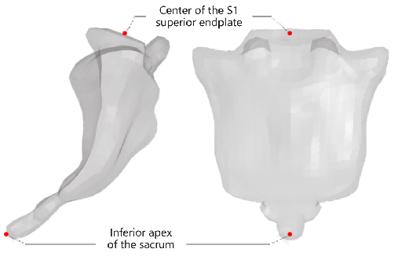
FigureA.1 Schematic of sacrum accelerometer setup
STEP1：Select all nodes on the superior endplate of the sacrum and calculate the center node as the location of S1.
STEP2：The tip of the sacral apex is defined as the location of S2.
A.2 Section Force Setup Method
Vertebral Section Force Setup Method:
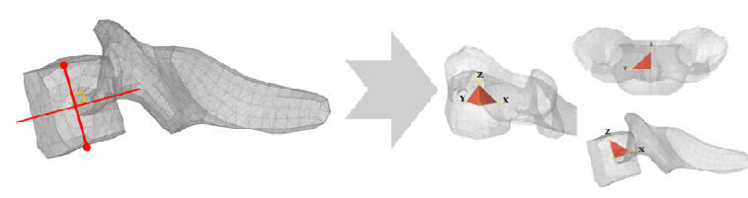
FigureA.2 Vertebral Section Force Setup Method
STEP1：The line connecting the geometric centers of the superior and inferior endplates of the vertebral body is defined as the Z-axis, with the midpoint of this line serving as the origin of the coordinate system. The symmetry plane of the vertebra is defined as the XZ plane of the coordinate system.
STEP2：Construct a tetrahedral sensor structure and establish a local coordinate system based on the tetrahedral nodes, aligning its orientation with the global coordinate system.
Pubic Symphysis Section Force Setup Method:
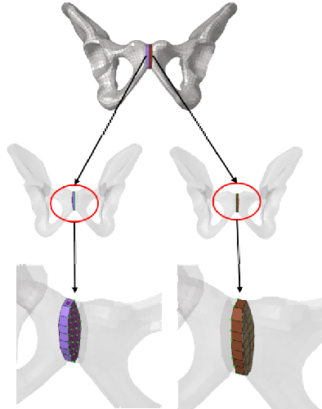
Figure A.3 Schematic of pubic symphysis setup
Figure A.3 illustrates the location of the pubic symphysis section force sensor. The section force output is requested using relevant keywords. Element sets containing both solid and shell elements are generated for the left and right pubic symphysis structures, while the node set consists of the common nodes shared by both sides.
Pelvic Section Force Setup Method:
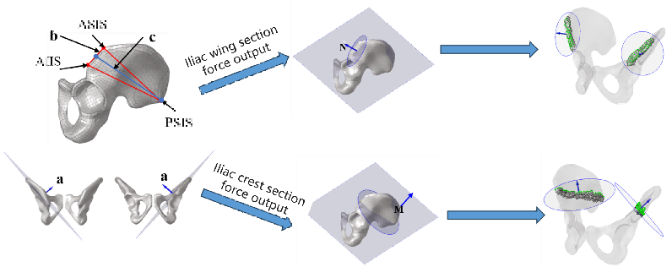
Figure A.4 Iliac force setup diagram
STEP1：A characteristic pelvic plane is defined by the three points: the Anterior Superior Iliac Spine (ASIS), the Anterior Inferior Iliac Spine (AIIS), and the Posterior Superior Iliac Spine (PSIS). The normal vector a of this plane is then calculated.
STEP2：Taking the cross product of vector a and vector b (formed by the ASIS and AIIS) yields the normal vector N for the required section. The section's origin is then appropriately positioned so that the section encompasses the ASIS and AIIS structures, using N as its normal vector.
STEP3：Vector c is defined by connecting the midpoint of the ASIS and PSIS to the PSIS. The normal vector M of the required section is derived from the cross product of vectors a and c. This section adopts M as its normal vector and sets its origin at the midpoint of vector c.
STEP4：Since the left and right pelvic sections are symmetrical, the data for the contralateral side can be directly derived from the model's symmetry plane, avoiding the repetition of previous steps. Setting up a local coordinate system is not required.
Methodology for lower limb long bone section force setup:
First, select the target plane for measuring the section force within the long bone. Next, identify any adjacent nodes and elements near this plane. Finally, establish a local coordinate system oriented in the required direction, using a node on the target section as the origin.
The femoral cross-sectional force is taken at the mid-diaphysis. For the tibia, cross-sectional forces are evaluated at both the proximal and distal ends of the tibial diaphysis, with the proximal section near the ligament insertion and the distal section near the ankle joint.
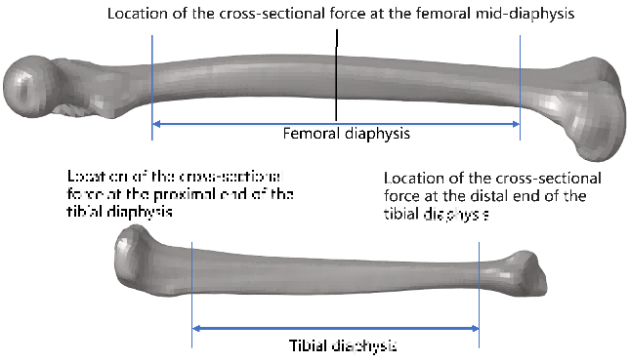
Figure A.5 Sensor Setup for Femoral and Tibial Cross-Sectional Forces
A.3 Setup Method for Deflection
Setup Method for the Mid-sternum Forward Compression Sensor:
Identify the intermediate node where the sternum connects with the 3rd and 4th ribs in the sagittal plane as the primary measurement node. Create a secondary node near the skin, sharing the same coordinates except for X, and tie it to the adjacent vertebra using *CONSTRAINED_NODAL_RIGID_BODY. A spring element (*ELEMENT_DISCRETE) is then defined between these two nodes. The relative displacement output via *DATABASE_HISTORY_DISCRETE serves as the sternal compression value.
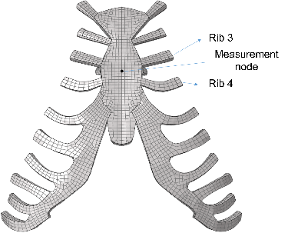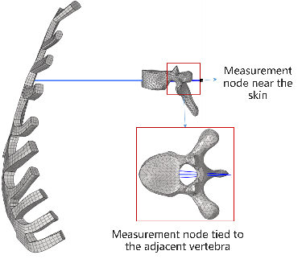
Figure A.6 Sternal Compression Sensor Setup Method
Method for Setting the Knee Ligament Compression Sensor:
Select two end nodes on the solid elements of the ligament and establish a spring element using *ELEMENT_DISCRETE. The relative displacement output via *DATABASE_HISTORY_DISCRETE represents the knee ligament compression.
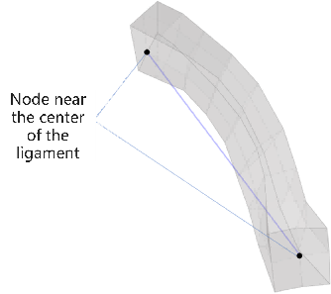
Figure A.7 Knee Ligament Measurement Node Selection
- Boundary Conditions for Calculation Cases
B.1 Thoracic Constraint Simulation Loading *, **
This simulation utilized three distinct types of shoulder belts combined with a disc loading device to apply loads to the occupant's chest. To ensure a consistent and standardized loading process, all impactors followed a fixed compression displacement curve (maximum displacement: 102 mm). The experiment directly outputted chest deflection and contact force, with the final results presented in terms of the chest deflection ratio.
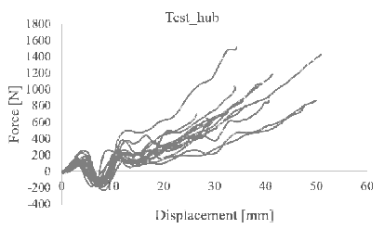 | 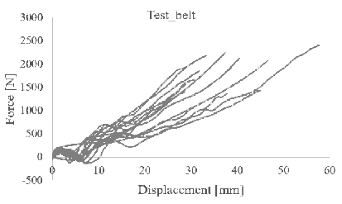
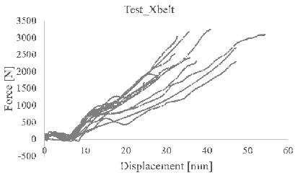 | 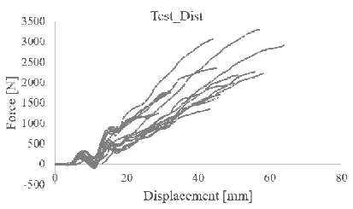
Figure B.1 Thoracic Constraint Simulation Loading Result Requirements
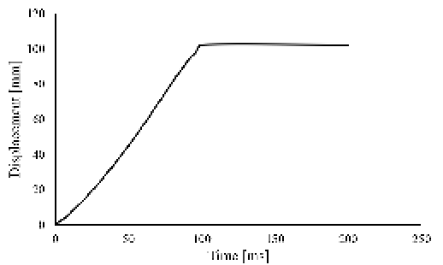
Figure B.2 Thoracic Constraint Simulation Loading Curve
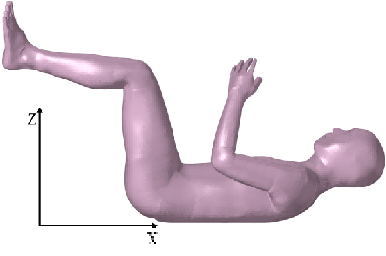
Figure B.3 Thoracic Constraint Simulation Loading Coordinate System
B.2 Oblique Lateral Chest Impact *
The simulation employed a 23.5 kg cylindrical impactor striking the right chest at 4.3 m/s. The impactor was oriented at a 15° angle relative to the X-axis, with its Z-axis position aligned with the xiphoid process. The resulting outputs were chest deflection and contact force.
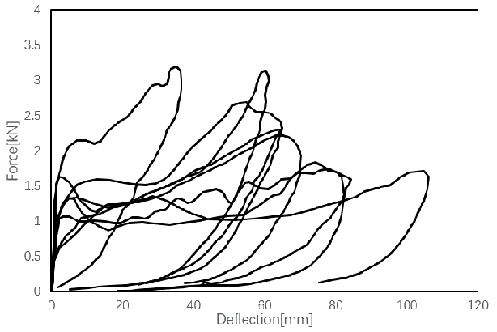
Figure B.4 Oblique Lateral Chest Impact Validation Curve
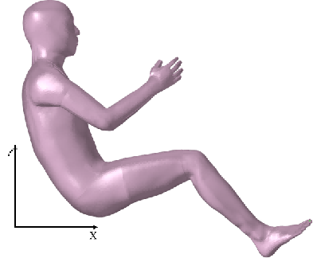
Figure B.5 Oblique Lateral Chest Impact Coordinate System
The center of the acetabulum is positioned at the origin of the global coordinate system. The coordinate directions are shown in the figure.
The occupant model is then rotated (with the acetabulum center as the origin) to align its sternal angle with that of the pedestrian model.
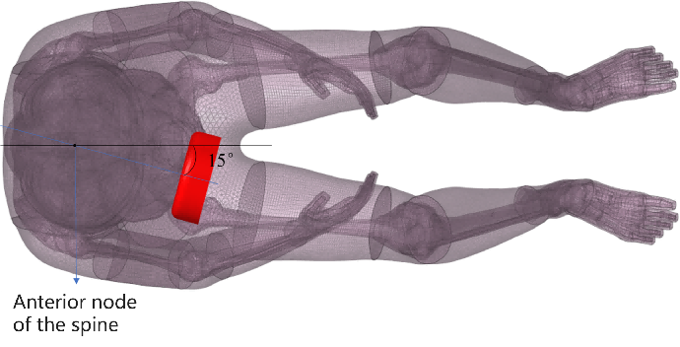
Figure B.6 Impactor Position
The line connecting the center of the impactor and the anterior aspect of the spine on the sagittal plane lies within the X-Y plane. The initial coordinates of the impactor share the same X and Z coordinates as the node at the tip of the xiphoid process. The impactor is initially positioned on the right chest of the occupant, with an impact direction and an axial angle of 15° relative to the X-axis. In the event of interference, the impactor is translated along the line connecting the anterior aspect of the spine and the center of the impactor to ensure an initial clearance of more than 50 mm between the impactor and the closest skin surface.
During the simulation, the Z-axis translation and all rotational degrees of freedom (DOFs) of the impactor are constrained. The impactor then impacts the aforementioned position on the right chest with an initial velocity of 4.3 m/s.
B.3 Localized Lateral Impact *
The simulation involved impacting the chest, abdomen, and pelvis at low, medium, and high speeds. Displacement-time and force-time curves were generated to serve as evaluation metrics. Subsequently, the simulated contact forces and impactor displacement-time histories were benchmarked against the experimental results for comparative analysis.
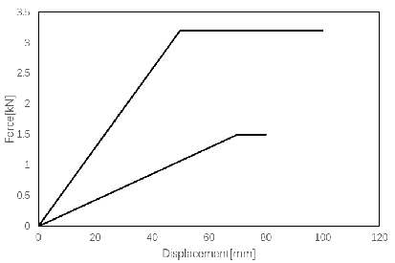 | 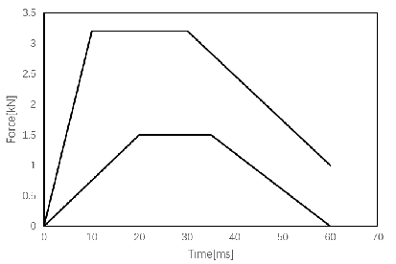
Low-Speed Chest Impact Corridor
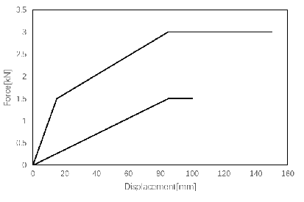 | 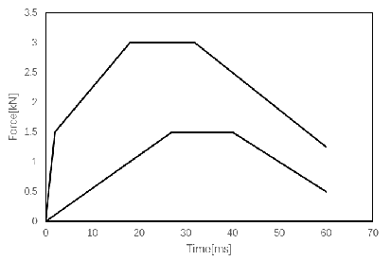
Low-Speed Abdominal Impact Corridor
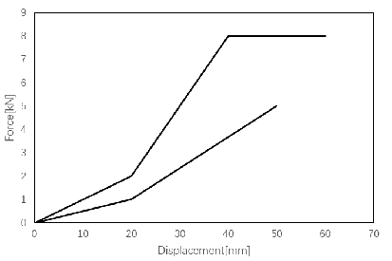 | 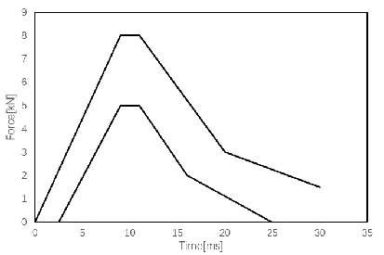
Low-Speed Pelvic Impact Corridor
Figure B.7 Low-Speed Impact Corridor
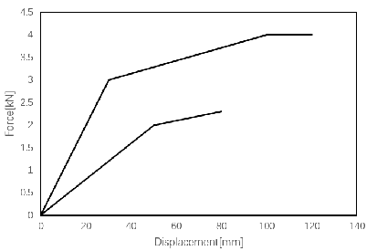 | 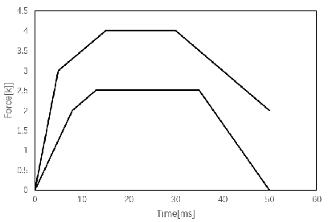
Mid-Speed Chest Impact Corridor
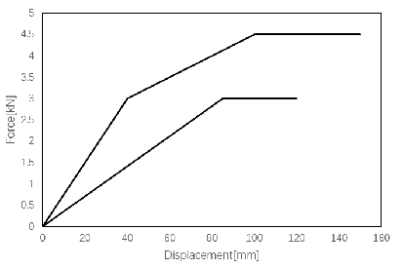
Mid-Speed Abdominal Impact Corridor
Mid-Speed Pelvic Impact Corridor
Figure B.8 Mid-Speed Impact Corridor
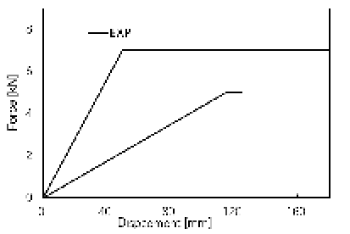 | 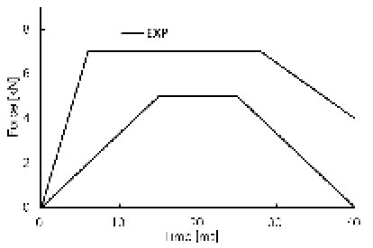
High-Speed Chest Impact Corridor
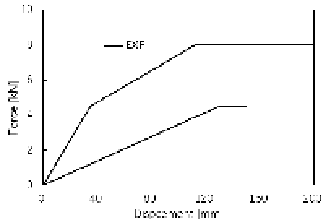 | 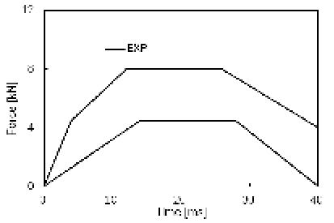
High-Speed Abdominal Impact Corridor
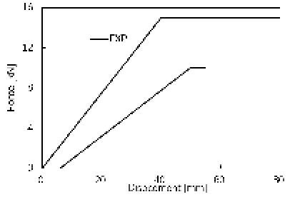 | 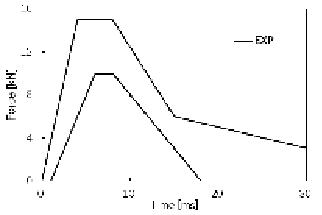
High-Speed Pelvic Impact Corridor
Figure B.9 High-Speed Impact Corridor
The boundary conditions for the localized lateral impact are shown in Table B.1.
Table B.1 Boundary Conditions for Localized Lateral Impact
 | Pelvic | Abdomen | Chest
Low-Speed [m/s] | 5.2 | 4.8 | 4.4
Mid-Speed [m/s] | 6.8 | 6.8 | 6.5
High-Speed [m/s] | 9.8 | 9.4 | 9.5

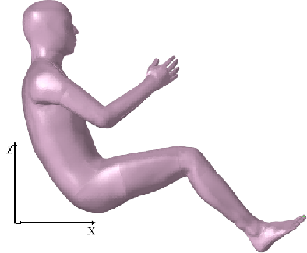
Figure B.10 Initial Coordinate Positioning
The acetabular center is positioned at the origin of the global coordinate system. Based on the sternum angle, the model is rotated about the coordinate origin to match the sternum angle of the standing model. All impactors are placed at an initial distance of at least 50 mm.
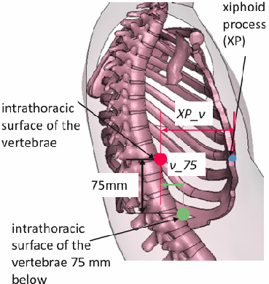
Figure B.11 Definition of Impact Location
The center of gravity (CG) of the chest is defined as follows: its Y and Z coordinates are identical to those of the xiphoid process, while its X coordinate is located 20 mm in the positive X-direction from the point on the outer surface of the spine. The chest impactor targets the chest CG, with the impact direction forming an angle of 330° relative to the X-axis. The chest impactor shares the same Z coordinate as the chest CG. In the event of interference, the impactor is translated along the line connecting it to the chest CG to ensure an initial clearance of more than 50 mm between the impactor and the skin.
The abdominal impactor targets the CG of the abdomen. The abdominal CG is defined as: its Y and Z coordinates are identical to those of the point on the outer surface of the spine, located 75 mm inferior to the chest CG; its X coordinate is located 20 mm in the positive X-direction from this same spinal surface point. The impact direction also forms an angle of 330° relative to the X-axis, and the abdominal impactor shares the same Z coordinate as the abdominal CG. Similarly, if interference occurs, the impactor is translated along the line connecting it to the abdominal CG to maintain an initial clearance of more than 50 mm between the impactor and the skin.
The impact location for the femur is the greater trochanter. The impact direction is aligned with the Y-axis (forming an angle of 270° relative to the X-axis). During impact, the center of the impactor shares the same X and Z coordinates as the greater trochanter, and the clearance between the impactor and the skin is maintained at greater than 50 mm.
In the simulation, the impact is executed by applying an initial velocity, while the Z-axis translation and all rotational degrees of freedom (DOFs) of the impactor are constrained.
B.4 Sled Frontal Impact *
The results of the frontal impact test cover multiple metrics, including the shoulder belt force, lap belt force, left and right knee bolster contact forces in the X-direction, foot contact forces in the Z-direction, seat-to-occupant reaction forces in the X/Z directions, as well as the head displacement in the X/Z directions.
For the GS2 load case results detailed below, the head displacement curves in the X and Z directions are mandatory assessment criteria.
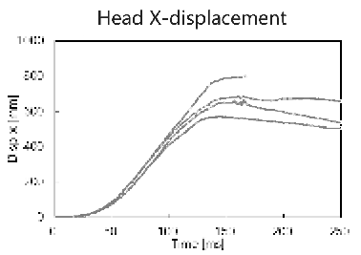 | 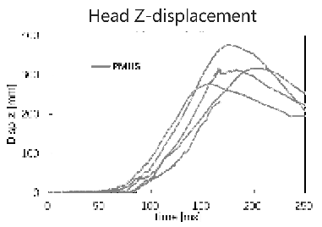
Figure B.12 Frontal Impact Test Result Curves
Simulation Load Case GS2: 30 km/h velocity, 3 kN load limiter, applied to the AM50 model.
The occupant is seated on a rigid flat seat, simulating a right-front passenger posture. The restraint system consists of a three-point shoulder-lap seatbelt.
Pelvic and lower extremity kinematics are constrained by a rigid aluminum knee bolster (contacting the proximal tibia) and an aluminum footplate with ankle straps. The initial positioning of the occupant model sets the H-point as the coordinate origin: palms are placed near the femoral heads, the knee bolster edge is positioned close to the tibial heads, and the soles are in full contact with the footplate model. Subsequent adjustments will be made according to the parameters in the table below.
The specific method for positioning the hands is as follows: align the X and Y coordinates of the midpoint of the distal radius cortical bone with those of the midpoint of the distal femur cortical bone. During the simulation setup, the bones can be temporarily rigidified, and spring elements can be used to stretch the arms until the hand skin comes into contact with the thigh skin.
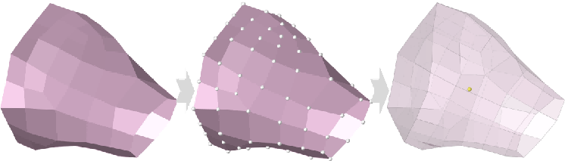
Figure B.13 Method for Establishing the Center Points of the Distal Radius and Distal Femur
Table B.2 Human Model Positioning Parameters
 | GS2(AM50)
H-point X-coordinate Offset | -11.0
Sternal Angle [°] | 22
Angle of Femur [°] | 10.0
Angle of Tibia [°] | 32.0
Sternal Angle: The angle between the Y-Z plane and the line connecting the midpoints of the articulations of the 2nd and 4th ribs with the sternum.
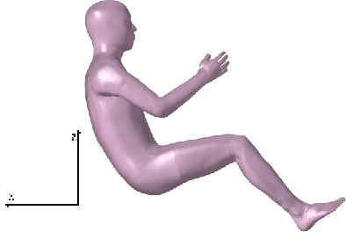
Figure B.14 Definition of Coordinate Directions
Femur and Tibia Angles: The angles between the femur/tibia and the X-Y plane, both defined as positive values.
The femoral angle is measured as the angle between the X-Y plane and the line connecting the lateral epicondyle of the femur and the center of the acetabulum. The tibial angle is measured as the angle between the X-Y plane and the line connecting the lateral epicondyle of the femur and the lateral condyle of the tibia. The measurement methods and landmark definitions are illustrated in the figure below:
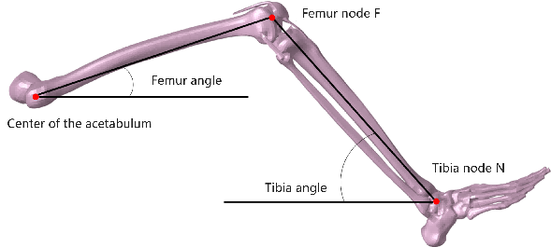
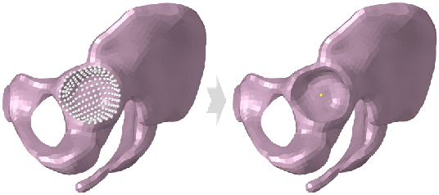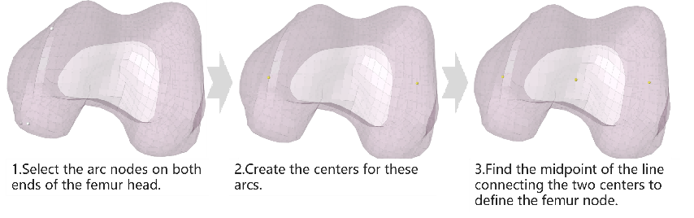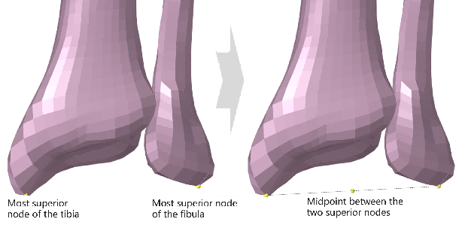
Figure B.15 Definitions of Femur and Tibia Angle
Seatbelt Anchor Positioning:
The metrics used are the seatbelt angle and the Z-axis distance between the sternum and the seatbelt. The anchor points can be translated along the Y and Z axes to adjust the seatbelt positioning parameters.
The seatbelt angle is defined as the angle between the X-Y plane and the line connecting the center of the left and right clavicles in the sagittal plane to the anchor point.
The Z-axis distance between the sternum and the seatbelt is defined as the distance along the Z-axis between the uppermost lateral node of the sternum and the midpoint of the shoulder belt contact area on the chest.
The positioning requirements are listed in the table below:
Table B.3 Positioning Metrics for Human Model, Seatbelt, and Seat
Case | Seatbelt Angle Range [°] | Z-axis Distance Range between Sternum and Seatbelt [mm] | Seat Vertical Travel Range [mm]
GS2 | 25-26 | 65-68 | ±5

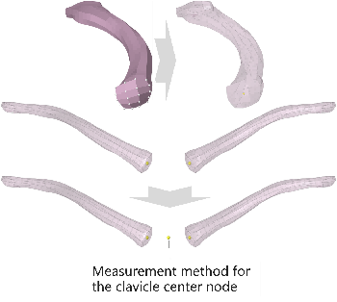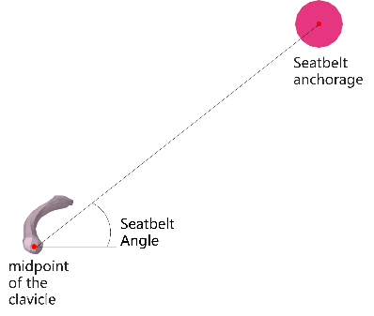
Figure B.16 Definition of Clavicle Center and Seatbelt Angle
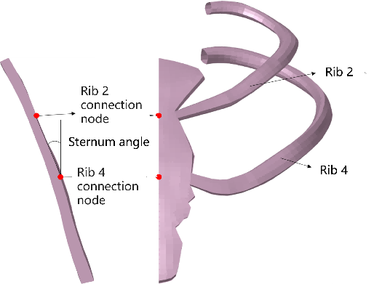
Figure B.17 Definition of Sternum Angle
A gravitational acceleration of 1g is applied to the simulation model throughout the process, and the translational degree of freedom along the Z-axis of the vehicle body is constrained. The acceleration pulse is applied in the positive X-direction.
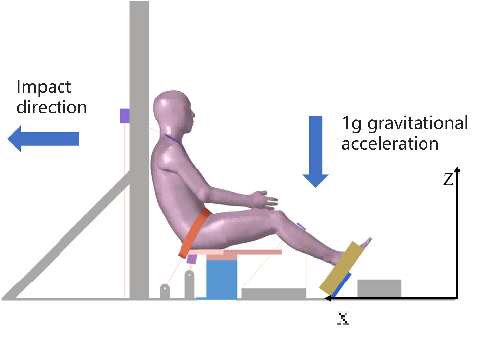
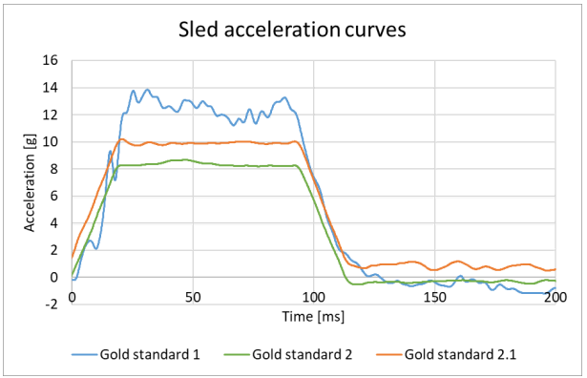
Figure B.18 Boundary Conditions and Acceleration Pulse for Frontal Impact
B.5 Frontal Sled Test with Airbag *, **
This frontal impact scenario compares the effects of different restraint system configurations on occupant chest injury. The restraint system for this crash condition is configured with a 2.5 kN load-limiting seatbelt and a 16 kPa pre-inflated airbag.
The test results for the frontal impact cover a wide range of metrics, including belt forces (lap and shoulder), seat contact forces in the X and Z directions, pedal contact forces in the X and Z directions, as well as the X, Y, and Z displacements of the head, T1, T8, L2, and pelvis. Among these, the X-direction displacement curves for the head, T1, T8, and pelvis are designated as mandatory assessment criteria.
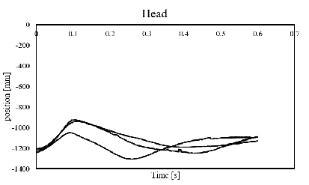 | 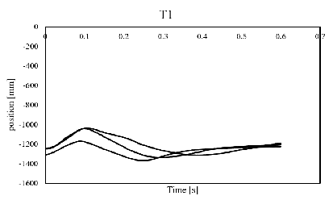
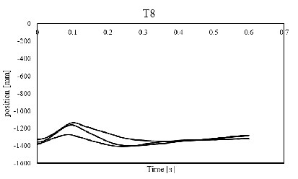 | 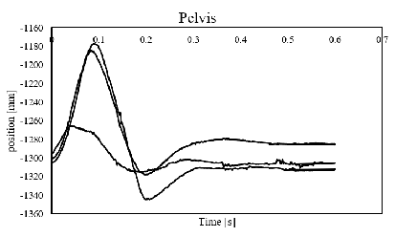
Figure B.19 Experimental Results for Case A
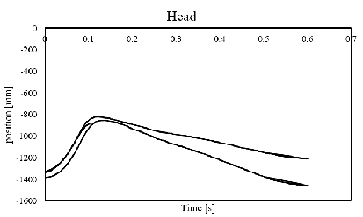 | 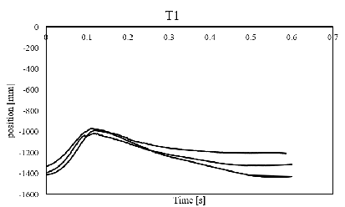
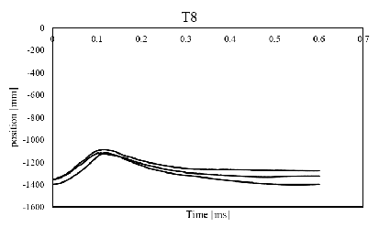 | 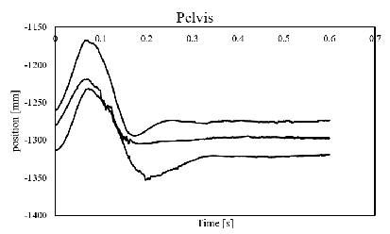
Figure B.20 Experimental Results for Case B
The subject was positioned on a rigid seat and restrained using a 3-point seatbelt (lap and shoulder belt). The palms were placed in a natural position on the thighs, with the soles of the feet in full contact with the pedals and the lower edge of the heels positioned near the junction of the pedal's horizontal and inclined surfaces.
Through pre-simulation, the deployed airbag was positioned on the steering wheel, with its specific location varying across different test cases.
Table B.4 Positioning Parameters for Frontal Impact
 | RCa
H-point X-position [mm] | 5.0
Sternum Angle [°] | 24.2
Airbag X-position [mm] | As close as possible to the dummy
Airbag Z-position [mm] | 707.0
After pre-simulation, check the positions of the seat and airbag.
Table B.5 Positioning Parameter Requirements after Frontal Impact Pre-simulation
 | Airbag X-position | Seat base
RCa | The inflatable airbag is positioned as close as possible to the HBM. | Aligned with the sled base in the Z-direction ±5mm
Figure B.21 Coordinate System Definition
Position the head in the Frankfort Horizontal plane.
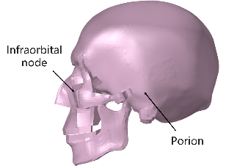
Figure B.22 Defining Feature Points of the Frankfort Horizontal Plane
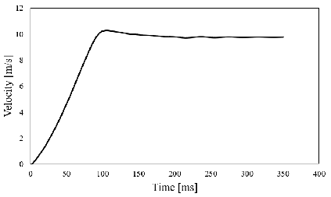
Figure B.24 Impact Velocity Curve
B.6 Far-side impact *
The virtual crash assessment is based on the side-impact sled tests conducted by Petit. The impact angle is set at 75° (whereas a pure side impact is defined as 90°).
The far-side impact results include: belt force, shoulder belt force, armrest contact forces (Y and Z), seat contact forces (Y and Z), pedal contact forces (Y and Z), as well as head displacement in the Y and Z directions. The head displacement curve is designated as a mandatory metric.
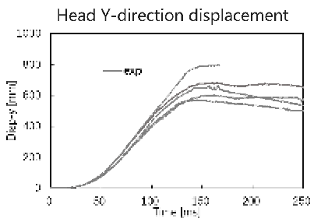 | 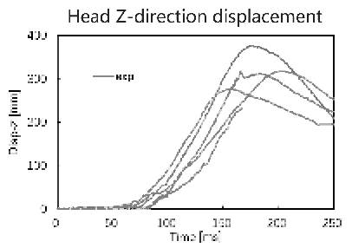
Figure B.25 Far-side impact test result curves
The sled model consists of a rigid seat, headrest, 3-point seatbelt, foam-covered center console (rigid), foot pedals, and a leg-side panel (rigid). The simulation crash duration is 200 ms. The seatbelt force limiter threshold is set at 0.1 kN. The peak velocities are Vx = 2.1 m/s and Vy = 7.9 m/s, with a peak acceleration of approximately 21.5 g.
The subject is positioned on the rigid seat and restrained by a 3-point lap-shoulder belt. The feet are in full contact with the pedals, with the lower edge of the heels positioned near the junction of the pedal's horizontal and inclined surfaces. The head is aligned with the Frankfort Horizontal plane.
The coordinate system is defined as follows:
Figure B.26 Coordinate System Definition
The H-point of the male model can be calculated based on the regression model.
Hip_x=214+0.616*stature-680*esh+7.21*age-0.392*H30+0.546*L6-0.00386*stature*age
Hip_z=533-1051*esh-25.1*BMI-0.182*age+0.935*H30+50.8*esh*BMI
Where stature is the height in mm, esh is the sitting height ratio, L6 is the distance between the steering wheel and the foot reference point in mm, BMI is the Body Mass Index (in kg/m²), and H30 is the seat height in mm.
A gravitational acceleration of 1g is applied to the simulation model throughout the entire process, while the vehicle body is constrained from moving along the Z-axis. The impact velocity is applied at an angle of 75° relative to the positive X-axis.
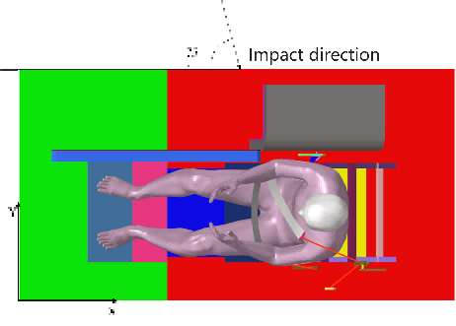
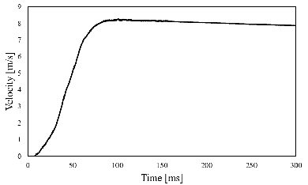
Figure B.27 Far-side Impact Validation: Boundary Conditions and Impact Pulse

：* Forman, J., Kulkarni, S., Rapela, D. P., et al. (2022). ** Kent, R., Lessley, D., and Sherwood, C. (2004).
* Yoganandan et al. (1997).
：* Viano, D. C. (1989).
注：* Shaw, G., Parent, D., Purtsezov, S., et al. (2009).
：* Lopez-Valdes, F. J. (2017). ** Lopez-Valdes, F. J., Mroz, K., Eggers, A., et al. (2018).
：* Petit, P., Trosseille, X., Uriot, J., et al (2019).

