
Technical requirements and test methods for calibration of AC-MDB aluminum honeycomb
No: WD-0004-20XX Ver: V1.0

Intelligent New Energy Vehicle All Domains Safety Association


※Drving Safety※
Technical committee
Drving Safety

Published：2026--xx-xx

Copyright © Intelligent New Energy Vehicle All Domains Safety Association（IADS）

Introduction

- Intelligent New Energy Vehicle All Domains Safety Association (referred to as IADS) is an international non-profit group standard organization established in Hong Kong in 2024. The vision of the organization is: "zero" casualties of life, "zero" dangers of health, "zero" loss of property, and "zero" disclosure of privacy. The mission of IADS is: to build an international platform for collaborative innovation and cooperation; to promote the establishment of all-domains safety standards and international application; to promote high-quality products and to protect the safety of drivers and passengers.
- IADS will regularly organize international exchange conferences, international standard development, standard promotion and other industry activities to support the efficient development of the automotive industry.
- This standard is published by IADS.
- The purpose of IADS standard is to serve the development of automobile industry, and the standard itself does not constitute mandatory. We encourage standard participants to put the IADS standard into use and provide them with valuable suggestions.
- All global automotive entities are welcome to participate in the formulation of IADS standards. If you have any questions about the standards, please contact the Secretariat of the Association.（Email：iadsafe@outlook.com）
Copyright

All rights reserved by IADS. Unless otherwise specified, this publication and its sections shall not be reproduced, republished, or used in any other form or by any means, including electronically, in photocopies, or posted on the Internet and Intranet, without permission. Licenses for use and distribution must be authorized by IADS. For further information, please contact the IADS Copyright Office：

Tel: +852 8483 0334 Email: iadsafe@outlook.com Website: www.iadsafe.org
Patent

The IADS standard was developed in accordance with the IADS patent policy.
Please note that implementation of this standard may require the use of subject matter covered by patent rights. By issuing this standard, IADS does not take any position on the existence or validity of any patent rights associated with it. If the patent holder or patent applicant has submitted a warranty statement by accepting the warranty letter, it will be listed on the IADS website at www.iadsafe.org. The warranty letter may indicate whether the author is willing or unwilling to grant a licence of the patent right without compensation or at a reasonable compensation rate, on reasonable terms and conditions that are manifestly not likely to result in any unfair discrimination against applicants who wish to obtain such a licence.
If a warranty has not been received, there may be an essential patent claim. IADS is not responsible for determining the essential patent requirements that may require a license, investigating the legal validity or scope of the patent requirements, or determining whether any license terms or conditions relating to the filing of the warranty, if any, or any license agreement are reasonable or non-discriminatory. Users of this standard are expressly advised that it is their sole responsibility to determine the validity of any patent rights and the risk of infringement of those rights. More information can be obtained from the IADS Standards Association.
Participants

Chair ------------------------------------------------------------------------------------- Yu Liu
Secretary -------------------------------------------------------------------------------- Hengping Zhao
Members
China Automotive Engineering Research Institute Co., Ltd.
Xi'an Composite Materials Co., Ltd.
Shenzhen Qianxingda Technology Co., Ltd.
OxSenses Co., Ltd
Principal Drafters of This Document:
Yu Liu, Hengping Zhao, Zhi Fu, Guojie Wang, Jin Fei, Enze He, Huanzi Liang, Jinzhou Ding
Thanks

OxSenses Co., Ltd.------------------------------------------------------------------------------XXX
Balloters

OxSenses Co., Ltd.------------------------------------------------------------------------------XXX
Contents

1. Overview 8
2. Scope 8
3. Normative references 8
4. Definitions, acronyms and abbreviations 8
4.1. Definition 8
4.1.1 Deformable barrier 8
4.1.2 Honeycomb aluminum block 8
4.1.3 Advanced Chinese Moving Deformable Barrier (AC-MDB) 8
4.1.4 Trolley 9
4.1.5 Load cell wall (LCW) 9
4.1.6 T-Shape fixture 9
4.1.7 Batch 9
5. Technical requirements 9
5.1 Structural characteristics of honeycomb 9
5.2 Dimensions and material characteristics 10
5.2.1 The main cellular block 10
5.2.2 Bumper cell block 11
5.2.3 Plate 11
5.3 Performance requirements of honeycomb aluminum calibration test 12
5.3.1 Static calibration test requirements 12
5.3.2 Dynamic calibration test requirements 14
6. Test method 16
6.1 AC-MDB static test calibration Test 16
6.1.1 Test conditions 16
6.1.2 Test equipment 17
6.1.3 Test procedure 17
6.2 AC-MDB Dynamic Calibration Test 17
6.2.1 Test Instruments 17
6.2.2 Test Facilities 17
6.2.3 Test Conditions 20
6.2.4 Test Procedures 21
6.2.5 Data Acquisition and Processing 21
7 Management Requirements 21
7.1 Traceability 21
7.2 Factory Inspection 22

Technical requirements and test methods for calibration of AC-MDB in Vehicle Crash Testing

- Overview
Side impact barriers used in automotive safety testing are critical test equipment for full-vehicle side impact assessments. The consistency and stability of their performance exert a significant influence on vehicle model evaluation results. The core component, honeycomb aluminum, must be scientifically calibrated and accompanied by specific technical requirements to ensure barrier reliability. This standard specifies the structural design, material characteristics, and calibration methods for honeycomb aluminum, covering both static tests (for verification of Force-Deformation curves) and dynamic tests (including: rigid load-cell wall test and T-shaped test). Furthermore, it defines factory inspection and quality control requirements to guarantee product performance consistency and traceability.
- Scope
This document specifies the technical requirements for AC-MDB used in vehicle crash tests, describes the corresponding test methods, and defines the inspection rules and administrative requirements.
This document applies to the manufacture of AC-MDB for vehicle side impact tests.
- Normative references
The following documents, through normative references herein, constitute essential provisions of this document. For dated references, only the edition corresponding to the cited date applies. For undated references, the latest edition (including all amendments) applies.
C-IASI Vehicle Occupant Safety Index – Side Impact Test Protocol (2026 Version, Revised 2026)
NHTSA TP-214D-09 DYNAMIC SIDE IMPACT PROTECTION
Euro NCAP 2020 Technical Protocol
NHTSA FMVSS 208 Occupant Crash Protection
SAE J211-1-2014 Instrumentation for Impact Test – Part 1: Electronic Instrumentation
ISO 6487 Road Vehicles – Measurement Techniques in Impact Tests – Instrumentation
ASTM C297-61 Standard Test Method for Flatwise Tensile Strength of Sandwich Constructions
- Definitions, acronyms and abbreviations
  - Definition

4.1.1 Deformable barrier
A test device used to simulate vehicle front-end structures, capable of controlled deformation in automotive crash tests.

4.1.2 Honeycomb aluminum block
A lightweight block core material composed of hexagonal cells fabricated through adhesive bonding of aluminum foil.

4.1.3 Advanced Chinese Moving Deformable Barrier (AC-MDB)
A deformable energy-absorbing device used in vehicle side-impact tests to characterize the average stiffness of vehicle front-end structures. It assesses crashworthiness of side structures and occupant protection performance.

4.1.4 Trolley
A wheeled frame structure designed to freely travel along the longitudinal axis toward an impact point. Its front end is equipped with frontal impact mobile deformable barriers.

4.1.5 Load cell wall (LCW)
A force measurement device comprising multiple load sensors integrated with a rigid wall, capable of recording impact forces during impact.

4.1.6 T-Shape fixture
An inverted T-shaped test fixture representing vehicle side structures, used for dynamic calibration tests of honeycomb aluminum.

4.1.7 Batch
Products of the same type and specifications manufactured using identical raw materials, during the same shift, and on the same production line.

- Technical requirements

5.1 Structural characteristics of honeycomb
The side impact moving deformable barrier structure meets the requirements of clause 6 of CIASI-SM.OS.SIT-C0 and consists of two parts: main honeycomb block and bumper honeycomb block. The structure is as shown in Figure 1.
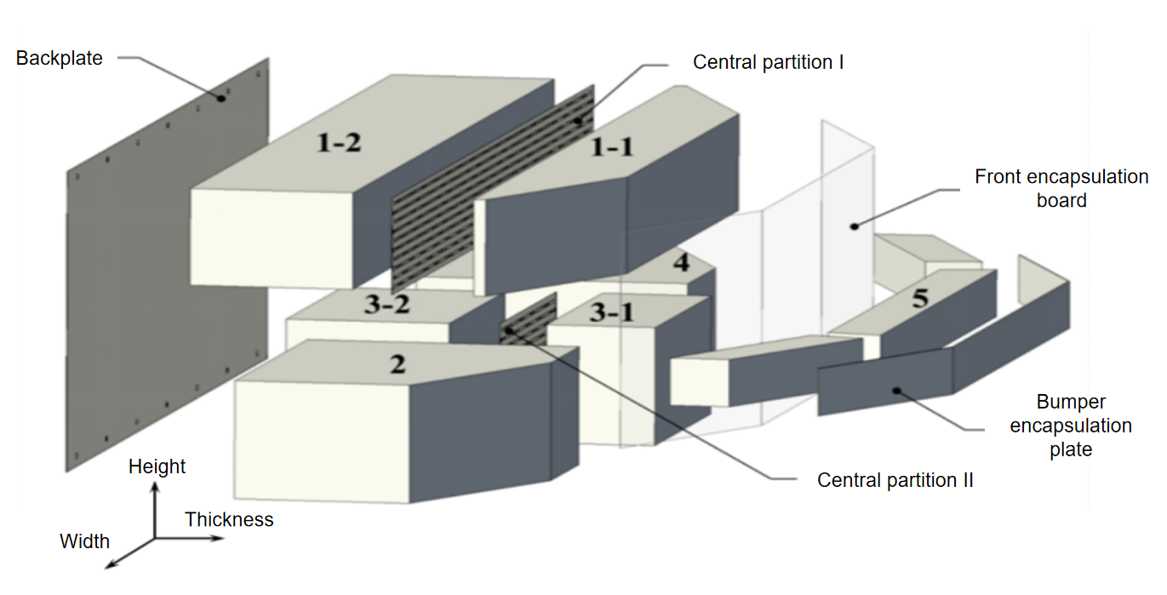
Figure 1: the barrier structure
1-1—Upper front-end honeycomb block；1-2—Upper rear-end honeycomb block；2—Lower right-side honeycomb block；3-1—Lower front-end honeycomb block；3-2—Lower posterior-end honeycomb block；4—Lower left side honeycomb block；5—Represents the bumper honeycomb block

5.2 Dimensions and material characteristics

5.2.1 The main cellular block

5.2.1.1 geometrical features
The external dimensions of the main honeycomb block are shown in Figure 2, and the geometric characteristics are shown below：
- The main honeycomb block consists of four parts: one upper honeycomb block (block 1) and three lower honeycomb blocks (block 2, block 3 and block 4), in which the upper honeycomb block and the lower middle honeycomb block are divided into two parts (block 1-1, block 1-2, block 3-1 and block 3-2)；
- The main size of block 1 is 1800mm ± 5mm 225mm ± 3mm; the main size of block 2 and 4 is 650mm ± 5mm 275mm ± 3mm; the main size of block 3 is 500mm ± 5mm 275mm ± 3mm.1800 mm, 650mm, and 500mm correspond to the W direction of the honeycomb aluminum structure, and 225mm and 275mm correspond to the L direction；
- The main honeycomb block is divided into two upper and lower rows. The chamfer shall be located in the most lateral part of the upper and lower row.
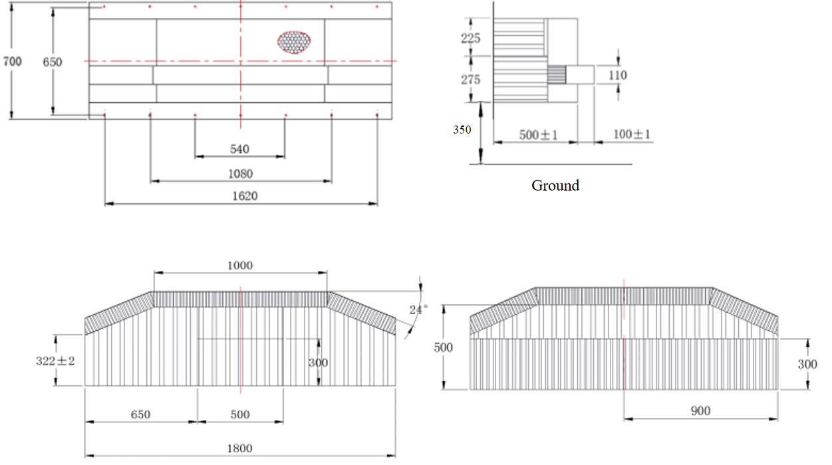
Figure 2: Overall dimensions of cellular aluminum main honeycomb block

5.2.1.2 Material characteristics
The material characteristics are as follows：
a）All blocks of the main honeycomb block shall be made of aluminum alloy with 3003;
b）The mass change of each honeycomb batch should not exceed 5% of the average honeycomb mass of each batch.

5.2.2 Bumper cell block

5.2.2.1 Geometrical features
The geometric properties are as follows：
- A bumper honeycomb block (block 5) was added to the lower front end of the main honeycomb block, bringing the overall thickness of the honeycomb aluminum up to 600mm ± 2mm. The bumper honeycomb block consists of three parts: a middle honeycomb block and two side honeycomb blocks;
- The main size of block 5 is 1800mm×100mm.1800mm corresponds to the W direction of the cellular aluminum structure, and 100mm corresponds to the L direction. As shown in Figure 5.2, for the external dimensions of the bumper honeycomb block.

5.2.2.2 Material characteristics
The material characteristics are as follows：
- Bumper honeycomb block shall be made of aluminum alloy with plate number 3003；
- The bumper honeycomb block shall be handled such that its strength at static extrusion is 0.32MPa±0.03MPa (as per the process defined in NHTSA TP-214D-09).

5.2.3 Plate

5.2.3.1 Geometrical features
The plates are divided into honeycomb aluminum backplane, middle partition board, front packaging board and bumper packaging board. See Figure 3 for the tolerances of all plate dimensions of ± 1mm.
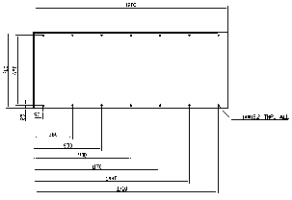  (a)Outline dimensions of the honeycomb backplane | 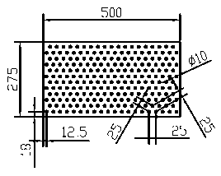  (b) Outline size of honeycomb middle partition plate
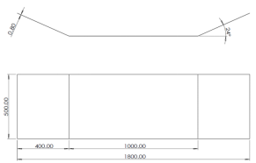  (c)Overall dimensions of the honeycomb front packaging plate | 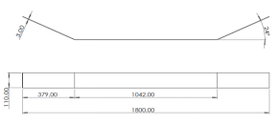  (d) Honeycomb bumper packaging plate external dimensions
Figure 3: External dimensions of the honeycomb aluminum partition plate

5.2.3.2 Material characteristics
The back, middle, front and bumper packaging panels shall be made of aluminum alloy plate 5052 H32.

5.3 Performance requirements of honeycomb aluminum calibration test

5.3.1 Static calibration test requirements
5.3.1.1 The manufacturer shall conduct one static calibration test for every 200 honeycomb aluminum barriers produced.
5.3.1.2 The stress-displacement curve characteristics of each sample shall be within the range of the static stiffness channel,as shown in Figure 4. All of the X-axis range of the corridors are from 6.4mm to 16.5mm.
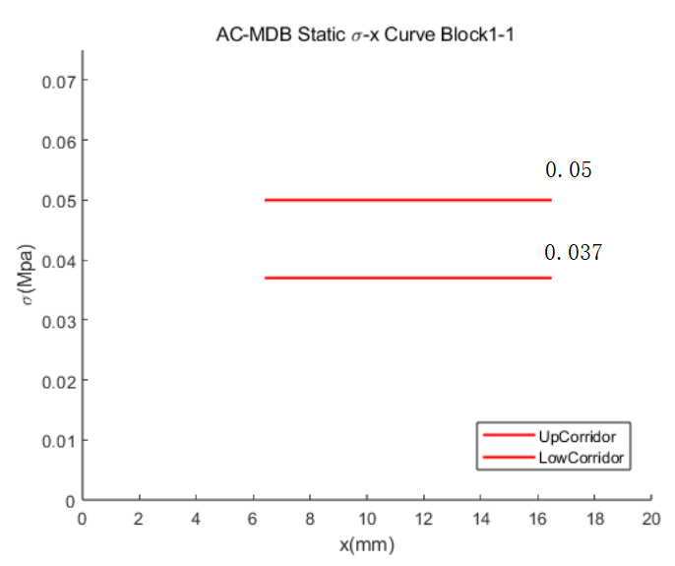  (a) Block 1-1 static stiffness requirements | 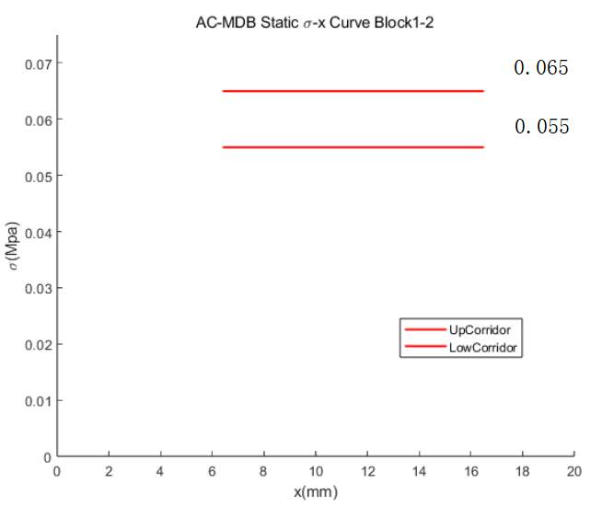  (b) Block 1-2 static stiffness requirements
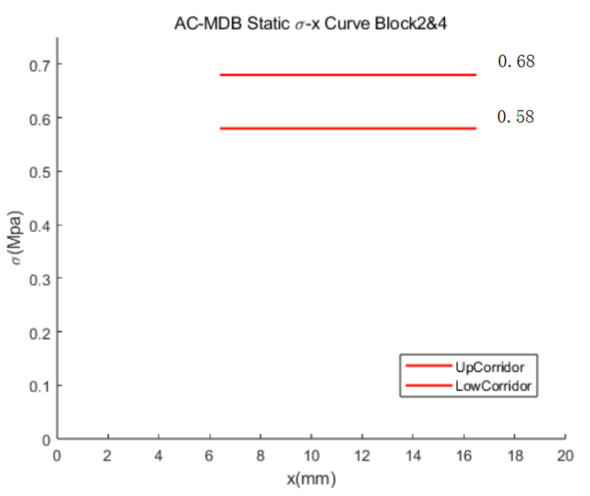
(c) Static stiffness requirements of blocks 2 and 4
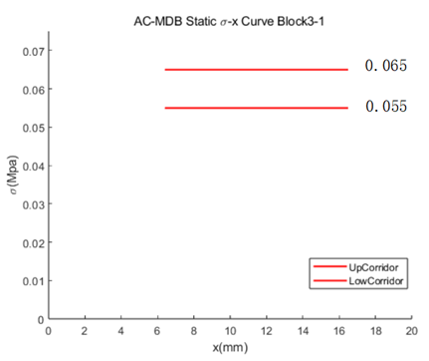  (d) Block 3-1 static stiffness requirements | 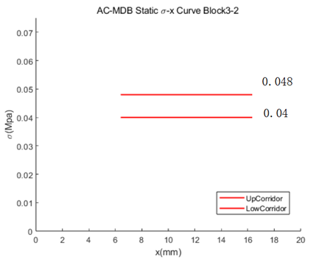  (e) Block 3-2 static stiffness requirements
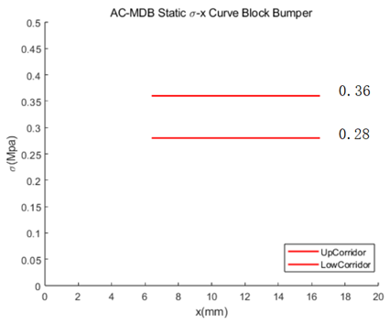
(f) Bumper static stiffness feature requirements
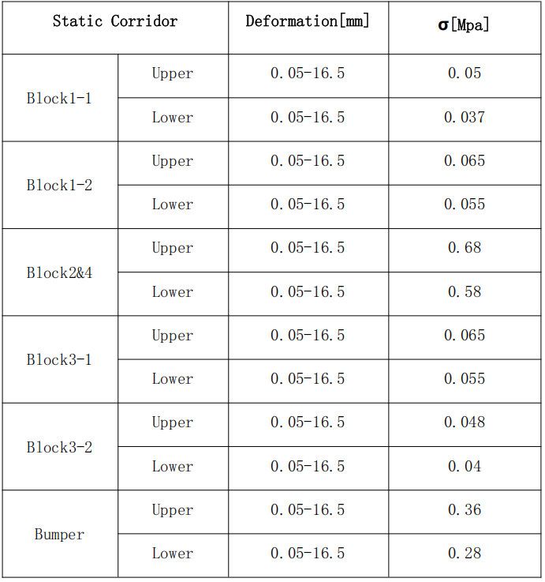
(g) Static requirements of all blocks
Figure 4: Requirements of the static stiffness channel of each block

5.3.2 Dynamic calibration test requirements
5.3.2.1 For every 200 honeycomb blocks produced, on-site sampling shall be carried out. After sampling, the manufacturer shall perform two dynamic calibration tests using a rigid load cell wall and an inverted T-shaped test fixture (referred to as the LCW test and the T-Shape test, respectively) to verify the stiffness performance of the honeycomb blocks.
5.3.2.2 The LCW dynamic calibration test
The force-displacement curve characteristics of honeycomb aluminum should be within the range of the LCW dynamic stiffness channel. As shown in Figure 5.
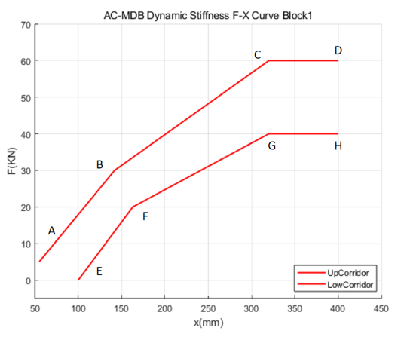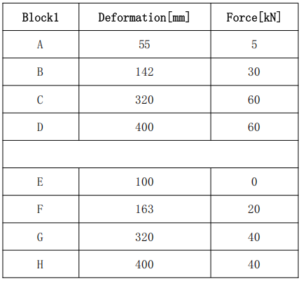
(a)Block 1 dynamic stiffness requirements in LCW
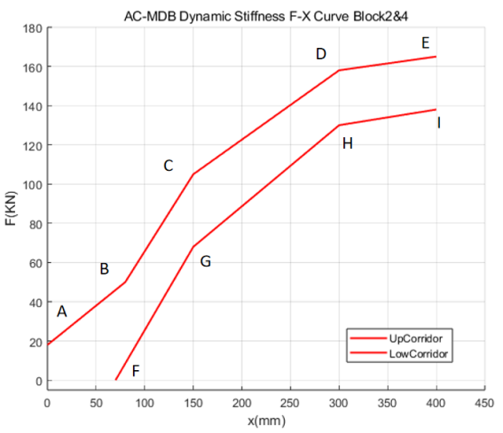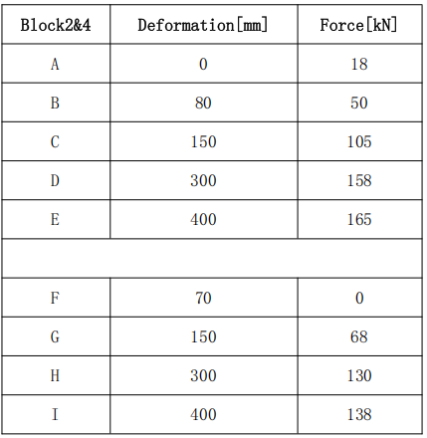
(b) Block 2 and block 4 dynamic stiffness requirements in LCW
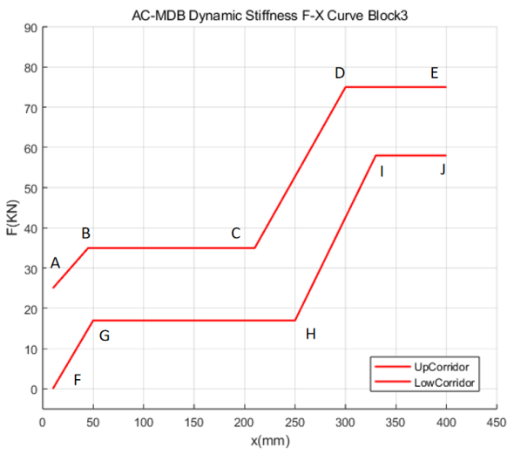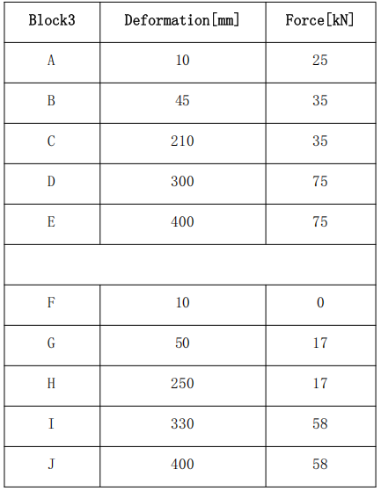
(c) Block 3 dynamic stiffness requirements in LCW
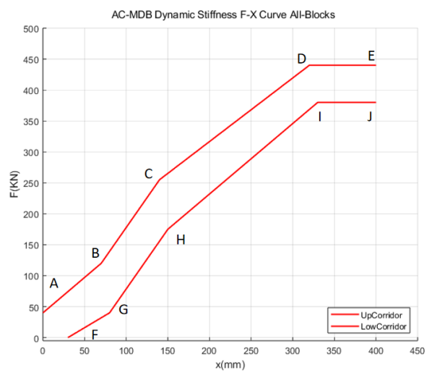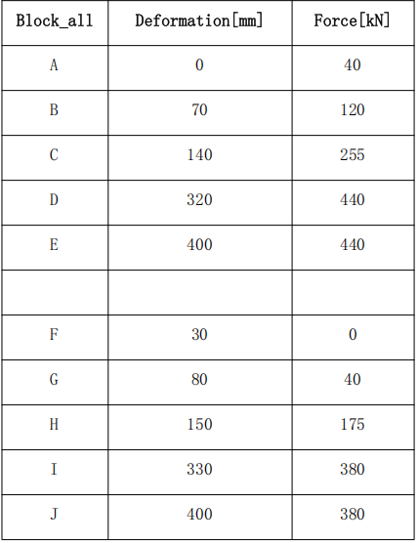
(d) the whole barrier dynamic stiffness requirements in LCW
Figure 5: Requirements for the dynamic stiffness channel of each block in LCW

5.3.2.3 T-Shape dynamic calibration test
The force-displacement curve characteristics of honeycomb aluminum should be within the range of T-Shape. As Shown in Figure 6.
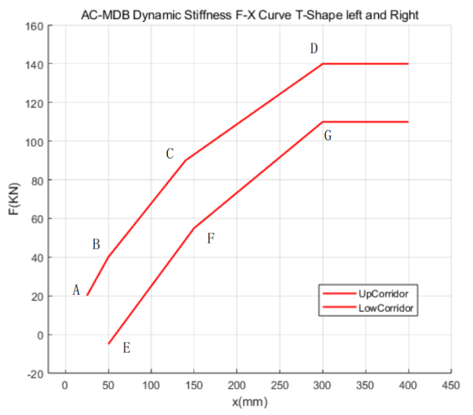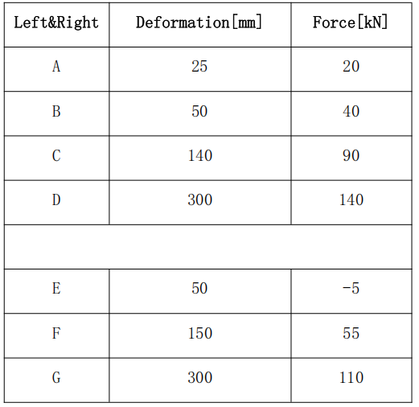
(a) Left and Right Corridors
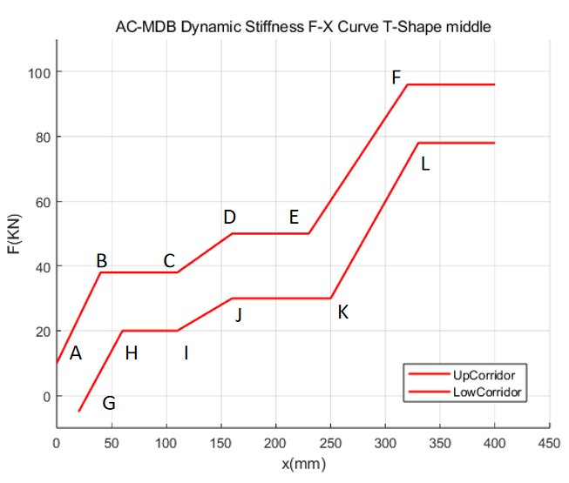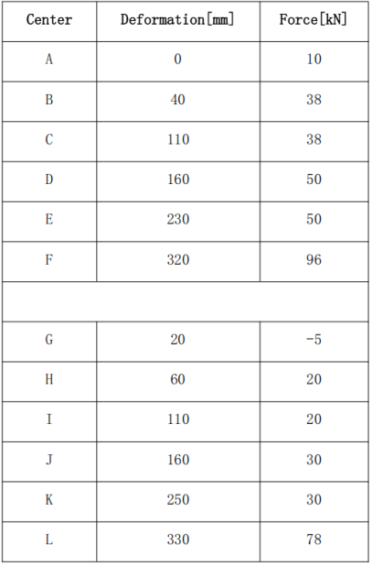
(b) Center Corridors
Figure 6: Requirements for T-Shape
- Test method

6.1 AC-MDB static test calibration Test

6.1.1 Test conditions
6.1.1.1 The compression speed shall be 100 mm/min, with an error of less than 5%.
6.1.1.2 The static calibration test shall be conducted continuously until all specimens are compressed by at least 300 mm for each block.

6.1.2 Test equipment
The requirements for test equipment and instruments are listed in Table 1.
Table 1: Equipment and instrument requirements
No. | Equipment/Instrument Name | Specifications/Accuracy
1 | Compression Testing Machine | Load accuracy < 0.1 kN
2 | Loading Plate | Extends 20 mm beyond the edge of the honeycomb block

6.1.3 Test procedure

6.1.3.1 Specimen preparation
From each batch of processed aluminum honeycomb, one or more specimens of the aluminum honeycomb core shall be extracted. The specimen dimensions for Honeycomb Block 1 are 500 mm × 225 mm × 200 mm, and for Honeycomb Blocks 2, 3, and 4 are 500 mm × 275 mm × 200 mm.

6.1.3.2 Specimen mounting
The specimen mounting procedure is as follows:
- Place the static test specimen at the geometric center of the loading plate, with the edges of the specimen parallel to the loading plate.
- Slowly move the loading plate downward until it contacts the specimen.

6.1.3.3 Test execution
Conduct the test according to the loading speed and termination conditions specified in 6.1.3. Ensure test results comply with the requirements of 5.3.1.2.

6.1.3.3 Data recording and processing
Continuously record force-displacement data for each specimen during the test. The minimum data sampling frequency shall be 5 Hz.

6.2 AC-MDB Dynamic Calibration Test

6.2.1 Test Instruments
The requirements for test equipment and instruments are listed in Table 2.
Table 2: Equipment and Instrument Requirements
No. | Equipment/Instrument Name | Specifications/Accuracy
1 | Data Acquisition System | Sampling frequency ≥ 10,000 Hz
2 | High-Speed Camera | Frame rate ≥ 500 fps
3 | Sensors (acceleration, force, displacement, etc.) | Linearity sensitivity ≤ 1% of indicated value
4 | Load Cell Wall | Linearity sensitivity ≤ 1% of indicated value

6.2.2 Test Facilities

6.2.2.1 Test Site
For indoor testing, the site shall be sufficiently large to accommodate the runway, moving deformable barrier (MDB) trajectory, test fixtures, and other equipment. The track end shall be flat and smooth at a distance of 5 meters from the test fixture.

6.2.2.2 Propulsion System
The system shall smoothly accelerate the mobile sled to the specified speed, with a towing acceleration ≤ 0.3g and speed error ≤ 0.2 km/h.

6.2.2.3 Lighting System
Adequate illumination shall be provided in the impact zone to ensure high-speed cameras capture clear footage of the impact process.

6.2.2.4 Load Cell Wall
The installation of load cells and surface cover plates shall comply with ISO 6487 Annex requirements. Specifics include:
a) The LCW dynamic calibration test shall use a 2m × 1m standard load cell wall, composed of 128 (16×8) load cells each sized 125mm × 125mm. The wall configuration is shown in Figure 7. The sum of forces measured by all load cells equals the total force exerted by the MDB during impact.
b) The load cell wall shall be mounted on a fixed rigid barrier made of reinforced concrete with a minimum width of 3 m, height of 1.5 m, and mass ≥ 70 tons. The barrier shall be anchored to the ground or secured with additional restraints to limit displacement.
c) The front panel of the load cell wall shall be perpendicular to the ground and aligned with the transverse centerline of the aluminum honeycomb block.
d) 12 mm ± 1 mm thick wooden plywood shall be affixed to each load cell surface for protection and to minimize response loss.
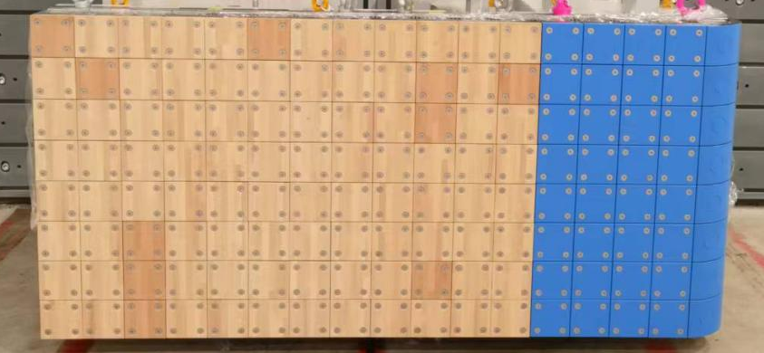
Figure 7: Schematic of Load Cell Wall

6.2.2.5 T-Shaped Test Fixture
The fixture consists of three rigid tubular columns and a polytetrafluoroethylene (PTFE) plate attached to the front of the central vertical column, with load sensors installed at the rear. Key requirements:
a) The T-shaped fixture shall be fixed to the rigid wall using clamping plates, with upper plates additionally secured to prevent deformation due to uneven force distribution. The fixture configuration is shown in Figure 8. Pressure plates shall be installed and tightened from the center outward.
b) The fixture may be directly connected to the load cell wall, or independent load-measuring devices may be placed between the fixture backplate and rigid wall. Load cells spanning multiple segments (left, center, right) shall not be used for data analysis unless unavoidable due to wall size limitations. Sensor layout is shown in Figure 9.
c) Vertically, the bumper component shall overlap the top surface of the fixture’s lower crossbeam by 75 mm ± 15 mm. The fixture centerline shall align with the aluminum honeycomb’s transverse centerline within ±15 mm. Alignment is illustrated in Figure 10.
d) Alignment verification shall use video analysis. Disposable markers (type and placement determined by the testing lab) on the fixture and honeycomb block must be visible to cameras.
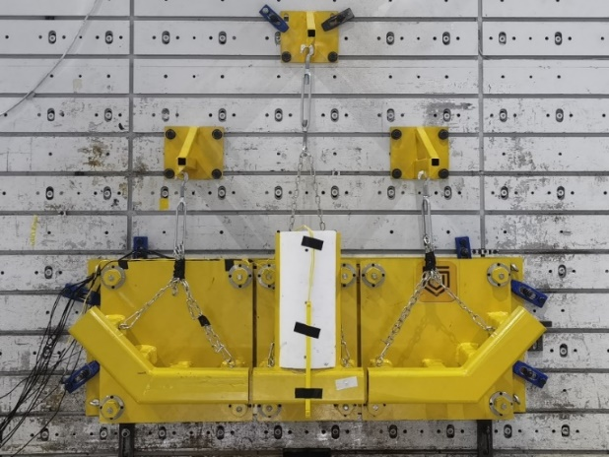
Figure 8: Schematic of T-Shaped Fixture
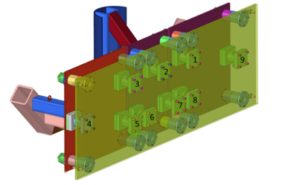
Figure 9: Load Sensor Layout for T-Shaped Fixture

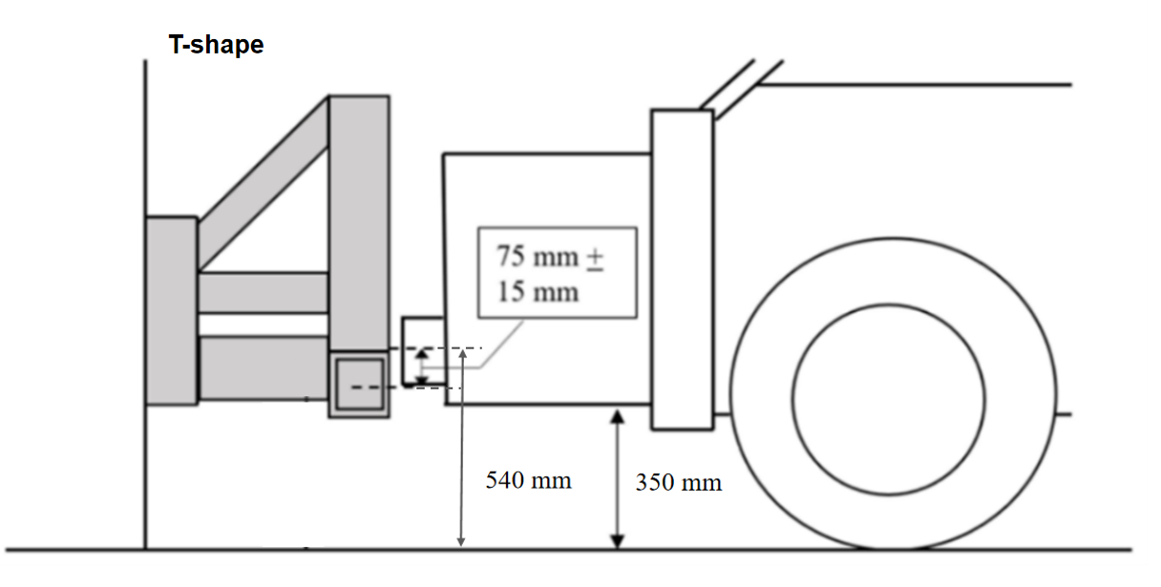
(a)Vertical alignment
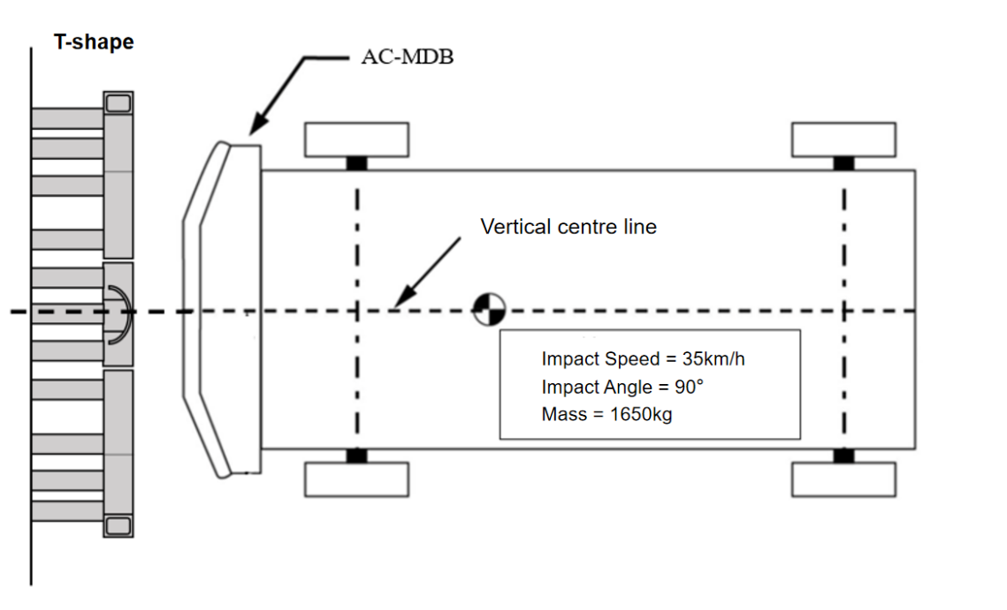
(b) Horizontal alignment
Figure 10: Alignment of T-Shaped Fixture and Barrier

6.2.3 Test Conditions

6.2.3.1 LCW Test Conditions
Impact speed: 50km/h ± 1 km/h.
Speed measurement accuracy: ≤ 0.1%.

6.2.3.2 T-Shaped Test Conditions
Impact direction: 90° perpendicular to the T-shaped fixture.
Impact speed: 35km/h ± 0.5 km/h.

6.2.4 Test Procedures

6.2.4.1 LCW Test Procedure
Prepare the AC-MDB according to GB 20071. Conduct the test under conditions specified in 6.2.3.1. Results shall comply with 5.3.2.2

6.2.4.2 T-Shaped Test Procedure
Prepare the AC-MDB according to GB 20071. Conduct the test under conditions specified in 6.2.3.2 Results shall comply with 5.3.2.3.

6.2.5 Data Acquisition and Processing
6.2.5.1 Place one accelerometer at a location close to the center of gravity on the transverse centerline of the moving deformable barrier to measure X-axis acceleration, and simultaneously install a set of backup accelerometers.
6.2.5.2 The time zero is recorded by a contact switch located on a structural component of either the rigid load cell wall or the inverted T‑shaped test fixture, which shall be the first to come into contact with the barrier surface.
6.2.5.3 After downloading the data from the data acquisition system, any initial offset from zero is removed from each channel by calculating the average of 100 data points prior to the impact (from 50 ms to 40 ms before impact) and subtracting this average from the respective data channel.
6.2.5.4 All measurement data shall be recorded at a sampling frequency of 10 kHz. The signals in all channels shall be converted simultaneously, so that the time references of different channels are not skewed.
6.2.5.5 For the LCW test, the data from the force sensors corresponding to each block of the aluminum honeycomb shall be summed to obtain the resultant force-displacement curve for each block. For the T‑Shape test, the data from the force measuring devices (left, center, right) within each segment shall be summed to obtain the resultant force-displacement curves for the left, right, and center segments, respectively. Data from any force measuring device that overlaps with more than one segment of the apparatus shall not be included in the calculation.
6.2.5.6 All data shall be digitally filtered using the Channel Frequency Class CFC 60 as defined in SAE J211-1-2014. The trolley displacement shall be obtained by double integration of the longitudinal acceleration.

7 Management Requirements

7.1 Traceability
7.1.1 The collision block should be engraved with a continuous serial number using etching or other permanent preservation methods, which should be able to trace the batch and production date of deformable barrier.
7.1.2 Each deformable barrier that leaves the factory should be accompanied by a corresponding inspection report, which should include but not be limited to:
a) Manufacturer information;
b) Deformable barrier serial number;
c) Batch information of honeycomb aluminum blocks;
d) The corresponding test results for this batch of honeycomb aluminum blocks.
7.1.3 The content of the factory inspection report shall comply with the provisions of Appendix C.
7.1.4 The corresponding information above should be kept for at least 10 years.

7.2 Factory Inspection
7.2.1 The factory shall establish quality control requirements and implementation plans for key components, key raw materials, key production processes, and finished products, and execute and retain corresponding records
7.2.2 The inspection agency shall inspect the quality control records of the automotive variable barrier production plant annually.

Annex A Factory inspection report (AC-MDB)
A.1 The factory inspection report shall include but is not limited to the following contents：
- Operative norm ；
- Product name / model number；
- Manufacture factory；
- Serial number of the deformable barrier；
- Static calibration test data record table and test curve, make data record of static calibration test according to Table A.1, and draw the force-deformation curve of each honeycomb aluminum block;
- Dynamic test report number for the corresponding lots of AC-MDB.
Table A.1 Static test record sheet for AC-MDB
Block No. | Series No. | Test Result
Block 1
Block 2
Block 3
Block 4
Block 5
Block 6

