
Test and Assessment Methods for Automotive Reclined Seat Occupant Protection in Frontal Impacts
No: WD-0001-20XX Ver: V1.0

Intelligent New Energy Vehicle All Domains Safety Association


※Drving Safety※
Technical committee
Driving Safety

Published：2026-xx-xx

Copyright © Intelligent New Energy Vehicle All Domains Safety Association（IADS）

Introduction

- Intelligent New Energy Vehicle All Domains Safety Association (referred to as IADS) is an international non-profit group standard organization established in Hong Kong in 2024. The vision of the organization is: "zero" casualties of life, "zero" dangers of health, "zero" loss of property, and "zero" disclosure of privacy. The mission of IADS is: to build an international platform for collaborative innovation and cooperation; to promote the establishment of all-domains safety standards and international application; to promote high-quality products and to protect the safety of drivers and passengers.
- IADS will regularly organize international exchange conferences, international standard development, standard promotion and other industry activities to support the efficient development of the automotive industry.
- This standard is published by IADS.
- The purpose of IADS standard is to serve the development of automobile industry, and the standard itself does not constitute mandatory. We encourage standard participants to put the IADS standard into use and provide them with valuable suggestions.
- All global automotive entities are welcome to participate in the formulation of IADS standards. If you have any questions about the standards, please contact the Secretariat of the Association.（Email：iadsafe@outlook.com）
Copyright

All rights reserved by IADS. Unless otherwise specified, this publication and its sections shall not be reproduced, republished, or used in any other form or by any means, including electronically, in photocopies, or posted on the Internet and Intranet, without permission. Licenses for use and distribution must be authorized by IADS. For further information, please contact the IADS Copyright Office：

Tel: +852 8483 0334 Email: iadsafe@outlook.com Website: www.iadsafe.org
Patent

The IADS standard was developed in accordance with the IADS patent policy.
Please note that implementation of this standard may require the use of subject matter covered by patent rights. By issuing this standard, IADS does not take any position on the existence or validity of any patent rights associated with it. If the patent holder or patent applicant has submitted a warranty statement by accepting the warranty letter, it will be listed on the IADS website at www.iadsafe.org The warranty letter may indicate whether the author is willing or unwilling to grant a licence of the patent right without compensation or at a reasonable compensation rate, on reasonable terms and conditions that are manifestly not likely to result in any unfair discrimination against applicants who wish to obtain such a licence.
If a warranty has not been received, there may be an essential patent claim. IADS is not responsible for determining the essential patent requirements that may require a license, investigating the legal validity or scope of the patent requirements, or determining whether any license terms or conditions relating to the filing of the warranty, if any, or any license agreement are reasonable or non-discriminatory. Users of this standard are expressly advised that it is their sole responsibility to determine the validity of any patent rights and the risk of infringement of those rights. More information can be obtained from the IADS Standards Association.
Participants

Chair ------------------------------------------------------------------------------------- Yu Liu
Secretary ---------------------------------------------------------------------------- Peifeng Wang
Members

China Automotive Engineering Research Institute Co., Ltd.------------- Yu Liu, Jing Fei, Peifeng Wang, Guojie Wang, Zheng Zhi, Kuo Cheng, Jie Jiang, Xingxing Feng, Qingzhu Luo, Weitao Xu, Hai Lin, Zhihan Yu
Hunan University-------------------------------------Zhonghao Bai, Qiang Wang, Xiaoting Yang
Li Auto Auto Technology Co., Ltd.-----------------------------------------Yajun Zhang, Kai Zhang
Autoliv (Shanghai) Automotive Safety System R&D Co., Ltd.-------Huangqing Zhu, Ruina Duan
Geely Automobile Research Institute (Ningbo) Co., Ltd.-------------------------Yutao Liu, Kun Li
Yanfeng Automotive Smart Safety System Co., Ltd.---------------------------Shuibo Wu, Fan Ni
Chongqing Chang'an Automobile Co., Ltd.----------------------------------------Ai Xu, Yong Liu
ZF Asia Pacific Automotive Safety Systems (Shanghai) Co., Ltd.--------Zhenfei Wang, Jing Wan
BYD Auto Industry Co., Ltd.-------------------------------------------------------------Feibing Lei
Ford Motor Engineering Research (Nanjing) Co., Ltd.-------------------------Ming Zhao, Tao Gu
Shanghai NIO Automobile Co., Ltd.---------------------------------Xinchao Zhao, Wenhua Yuan
Adient (Chongqing) Automotive Components Co., Ltd.------------------------------Ming Zhang
SERES Automobile Co., Ltd.------------------------------------------------------------Juying Hou
Zhejiang Songyuan Automotive Safety System Co., Ltd.------------------------------Hong Zhao
Fuzhou Lianhong Traffic Equipment Co., Ltd.----------------------------------------Jixiong Deng
Thanks

XXXX Co., Ltd.------------------------------------------------------------------------------XXX

Balloters

XXXX Co., Ltd.------------------------------------------------------------------------------XXX

Test and Assessment Methods for Automotive Reclined Seat Occupant Protection in Frontal Impacts

- Overview
This standard specifies the test and assessment methods for occupant protection of reclined seats in frontal rigid barrier (hereinafter referred to as "FRB") and frontal 50% overlap moving progressive deformable barrier (hereinafter referred to as "MPDB") sled collisions, and active safety function test methods includes deactivation function test, warning function test and dynamic test.
- Scope
This standard applies to M1 and N1 category vehicles equipped with automotive reclined seats that can be adjusted to a cushion angle ≥ 15° and torso angle ≥ 35° for use while the vehicle is in motion.
Other vehicle models equipped with such reclined seats may refer to this standard.
- Normative references
The following documents are indispensable for the application of this document. For dated references, only the edition cited applies. For undated references, the latest edition (including any amendments) applies.
GB 15083, Strength requirements and test methods of automobile seats, their anchorages and any head restraints
ISO/TS 17242:2014, Quasi-static calibration procedure for belt force transducers
GB/T 29120-2012, Procedures for determining H-point and R-point
ISO 6487, Road vehicles - Measurement techniques in impact tests - Instrumentation
- Definitions, acronyms and abbreviations

4.1 Definition
For the purposes of this document, the terms and definitions given in GB 15083 and the following apply.

4.1.1

Vehicle Reclined Seat
A seat equipped with a calf rest and an adjustable cushion, where adjusting components such as the cushion, backrest, calf rest, or foot rest results in an occupant posture different from the traditional sitting posture, specifically, the cushion angle ≥ 15° and torso angle ≥ 35°, measured according to 5.3.1 using the HPM-II 3-D H-point machine.

4.1.2

Reclined Seat Test Angle
The seat cushion angle and torso angle of the automotive reclined seat when actually set for testing.

4.1.3

One-Click Zero Gravity Position
A position where the seat is adjusted, with a single trigger of a seat adjustment button or other functional device, to a position meeting the criteria of cushion angle ≥ 15° and torso angle ≥ 35° measured according to 6.3.1.

4.1.4

Seat Calf Rest
A device extending from the front of the seat or other interior components used to support the occupant's legs for additional comfort.

4.1.5
Seat Foot Rest
A device used to support the occupant's feet for additional comfort.

4.1.6
All Belt to Seat (ABTS)
A seat where all seat belt anchorage points are installed on the seat itself, allowing the seat belt fitment to adapt to different seat adjustment positions.

4.1.7
Seat Target Position
The seat position achieved by adjusting the slide rail travel, various seat component angles, and states to meet the test requirements for the reclined seat.

4.1.8
Seat Standard Position
The seat position adjusted from the target position to determine the reference pelvis angle and target pelvis angle.

4.1.9
Pelvis Angle for Reference
The angle formed between the line connecting the center of the lowest lumbar intervertebral disc and the occupant's H-point and the vertical plane.

4.1.10
Target Pelvis Angle
The angle measured by the dummy's pelvis tilt angle sensor.

4.1.11

Normal Vehicle Operating State
The vehicle is moving in the forward direction at a speed greater than 10 km/h.

4.1.12

Deactivation Function
A function that prevents use of the vehicle reclined seat when certain conditions are met. The deactivation function shall be activated under one of the following conditions:
a) The seat shall return from the zero gravity position to the design position then the vehicle can be driven;
b) While the vehicle is in motion, when the vehicle speed does not exceed 25 km/h or the driving distance does not exceed 500 m in normal operating state, the automatic retract function shall be activated to return the seat from the zero gravity position to the OEM defined torso angle (≤35°) within 60 s.
NOTE: The one-click zero gravity function shall not be activated while the vehicle is in normal operating state.

4.1.13

Warning Function
After start or while driving, when the seat is at zero gravity position, a visual and audible warning (If voice information is used, the message content relates to the vehicle reclined seat) shall be activated for more than 30 s under either condition a) or b):
a) The vehicle speed does not exceed 25 km/h or the driving distance does not exceed 500 m in normal operating state.
b) Torso angle adjusted from <35° to ≥35° while driving. The warning may cease once the seat returns to <35°.

4.1.14
Emergency Retract Function
This refers to a situation where, while the vehicle is in motion, if the seat is in zero gravity position and the vehicle’s Automatic Emergency Braking (AEB) system detects an unavoidable collision, the seat automatically returns from the zero gravity position to a safer occupant protection position before the collision occurs.

4.1.15
Anti-pinch Function
No compression shall be exerted on occupants of adjacent seats during the seat adjusted to the zero gravity state.

4.2 Acronyms and abbreviations
MPDB Frontal 50% Overlap Moving Progressive Deformable Barrier
FRB Frontal Rigid Barrier
ABTS All Belt to Seat
HPM-II 3-Dimensions H-point Machine II
HIC Head Injury Criterion
TI Tibia Idex
TP Target Position
BP Backrest Point
SP Standard Position
SC Seat Center
SOA Seat Opening Angle
CMM Coordinate Measuring Machine
CCRs Car-to-Car Rear Stationary

- Assessment Methods

5.1 General Requirements
If the vehicle is equipped with a one-click zero-gravity function, it shall comply the following requirements:
5.1.1 If the vehicle is equipped with a deactivation function, it shall meet the requirements of Section 4.1.12 .
5.1.2 If the vehicle is not equipped with a deactivation function, it shall meet the following requirements:
5.1.2.1 The warning function shall meet the requirements of Section 4.1.13.
5.1.2.2 The emergency retract function shall meet the requirements of Section 4.1.14.

5.1.3 The anti-pinch function shall meet the requirements of Section 4.1.15, with or w/o the deactivation function.

5.2 Techical Requirements
5.2.1 After conducting the MPDB or FRB test according to the test methods in Clause 5, the test results shall satisfy the technical requirements in 5.1.2 to 5.1.8.
5.2.2 The frontal airbag shall not deploy dangerously. An area 150mm in front of the dummy's face, perpendicular to the vehicle's longitudinal plane, is defined as the head assessment area. Within this area, the airbag shall not sweep across the dummy's face horizontally or vertically, posing a potential risk to the dummy's face or eyes. The airbag deployment rate shall be ≤ 90 m/s.
5.2.3 No two or more hard contacts of the head shall occur. The occupant's head shall not contact vehicle interior components during the impact. If contact occurs, there shall be at most one peak resulting in head resultant acceleration exceeding 70g due to contact between the occupant's head and vehicle interior components.
5.2.4 Shoulder belt force shall be ≤ 6 kN.
5.2.5 The dummy shall not submarine during the impact. If, during the dummy's forward movement relative to the vehicle, high-speed video confirms the lap belt slips over the pelvis, or there is a sudden drop in either left or right iliac force within 1 ms (iliac force drop rate ≥ 500 N/ms), the dummy is considered to have submarined.
5.2.6 When releasing the dummy from the restraint system after the impact, the seat belt buckle shall release normally, with release force ≤ 60 N.
5.2.7 The seat shall not fail in a manner that endangers occupant safety during the impact.
5.2.8 After data processing according to 6.6, and calculating indices per Annex A, the dummy injury criteria technical requirements in Table 1 shall be met simultaneously.
Table 1 — Dummy Injury Criteria Technical Requirements
Dummy Injury Criterion | Technical Requirement
Head HIC15 | ≤840
Upper Neck Shear Force Fx | ≤3.1 kN
Upper Neck Tension Force Fz | ≤3.3 kN
Upper Neck Extension Moment Mocy | ≤57 N·m
Abdominal Pressure P | ≤2.69 bar
Femur Compression Force Fz | ≤9.07 kN @0 ms  and ≤7.56 kN @10 ms
Acetabulum Compression Force F_{AR} | ≤4.1 kN
Iliac Compression Force Fx | ≤4.5 kN
Lumbar T12 Compression Force Fz | ≤6.5 kN
Knee Sliding Displacement D | ≤18 mm
Tibia Index (Upper/Lower) TI | ≤1.2
Tibia Axial Force Fz | ≤8.0 kN
Foot Resultant Acceleration a | ≤260g
Note: The femur compression force Fz requirement means the femur compression force cumulative curve shall fall within the gray box range shown in Figure 1.
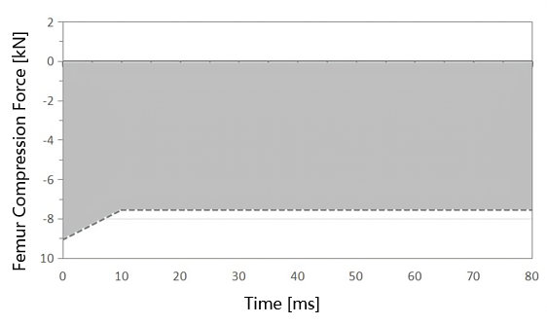
Figure 1 — Femur Compression Force Cumulative Curve

- Passive Safety Test Methods

6.1 Pre-test Preparation
6.1.1 Sample Preparation
6.1.1.1 Ensure the functional configuration of the prepared reclined seat and the specifications of the restraint system match those of the actual vehicle model equipped with the reclined seat, with no obvious damage or deformation.
6.1.1.2 Prepare the seat fixture and corresponding body mounting bolts simultaneously.
6.1.1.3 If the seat is equipped with seat belt pretensioners, airbags, or other protective measures, provide the corresponding deployment timing. For special deployment devices, provide the necessary tools and equipment (e.g., wiring harnesses).
6.1.1.4 The body frame and floor need reinforcement. Camera mounts shall be installed at the corresponding test positions, referencing Figure 4.
6.1.1.5 The reclined seat shall be tested on a body-in-white or test fixture. The corresponding front seat or center console shall be placed before the test. If testing on a body-in-white, all interior components affecting dummy motion shall be assembled.
6.1.1.6 Measures taken to protect the test dummy shall not reinforce the seat anchorages or seat belt anchorages, nor prevent normal structural deformation. No additional components shall be present on the fixture or body-in-white that restrict dummy movement to reduce loads on the dummy during the test.
6.1.1.7 For reclined seats with non-integrated seat belts, provide the vehicle seat belt and its anchorage point coordinates. If necessary, provide corresponding mounting fixtures to replicate the actual vehicle seat belt configuration.
6.1.2 Sample Preparation
6.1.2.1 For some seats, after power connection, all functional movements can be controlled directly by the seat module via switches.
6.1.2.2 For other seats requiring separate external wiring harnesses and power supply to control movement, accurately locate the motor connector area needing external wiring. Visually inspect and lightly feel to identify the shape and material of foam, plastic parts, armrests, or back panels obstructing external wiring. Use appropriate tools (e.g., cutters, grinders) to cut, grind, or remove obstructions to successfully install the external wiring harness.
6.1.2.3 Connect the power supply and adjust all functions to ensure all relevant motor-driven functions operate normally.
6.1.3 Seat and Seat Belt Installation
6.1.3.1 Based on the measured coordinates of the seat slide rail mounting points on the actual vehicle, position the corresponding seat fixture at the designated location to accurately simulate the actual vehicle installation state, and secure it.
6.1.3.2 Align the seat slide rail positioning pins with the fixture's positioning holes, accurately place the seat, and ensure it is firmly installed.
6.1.3.3 For installation on a body-in-white, follow the same steps as above, referencing the actual vehicle seat position for installation.
6.1.3.4 For both integrated and non-integrated seat belts on reclined seats, the seat belt configuration shall replicate the actual vehicle state. Adjustable mechanisms shall be positioned according to design specifications. If no design position is specified, a suitable position shall be determined by the on-site engineer (e.g., for height adjusters: "set to the one-click zero gravity position"; if no design position, set to the lowest locked position; if the lowest locked position causes interference, adjust upwards to the nearest non-interfering locked position).

6.2 Test Conditions
Secure the seat and fixture onto the impact sled. Place the modified THOR-50M dummy on the seat according to 6.4. Conduct FRB test and MPDB test with acceleration changes meeting the pulse requirements in 6.2.2.
6.2.1 Test Environment
The test laboratory temperature shall be 23℃ ± 2℃, relative humidity 10% to 70%.
Before the test, the modified THOR-50M test dummy and the seat shall be stored in this environment for at least 4 hours.
6.2.2 Test pulse Requirements
The test pulse shall simulate MPDB and FRB impacts. The test pulse shall fall entirely within the shaded areas of the pulse corridors shown in Figures 2 and 3. The vehicle speed shall be 50 km/h with a tolerance of -1 km/h to +1 km/h. Tables 2 and 3 provide the key point coordinates for the upper and lower bounds of the pulse corridors.
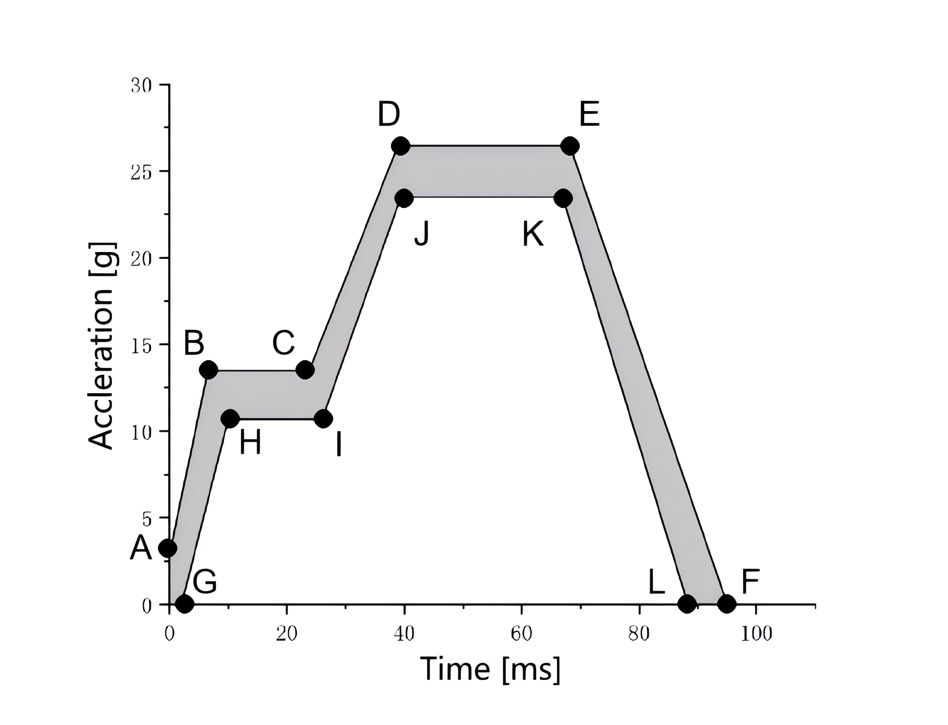
Figure 2 — Sled Deceleration or Acceleration pulse Corridor for MPDB Test
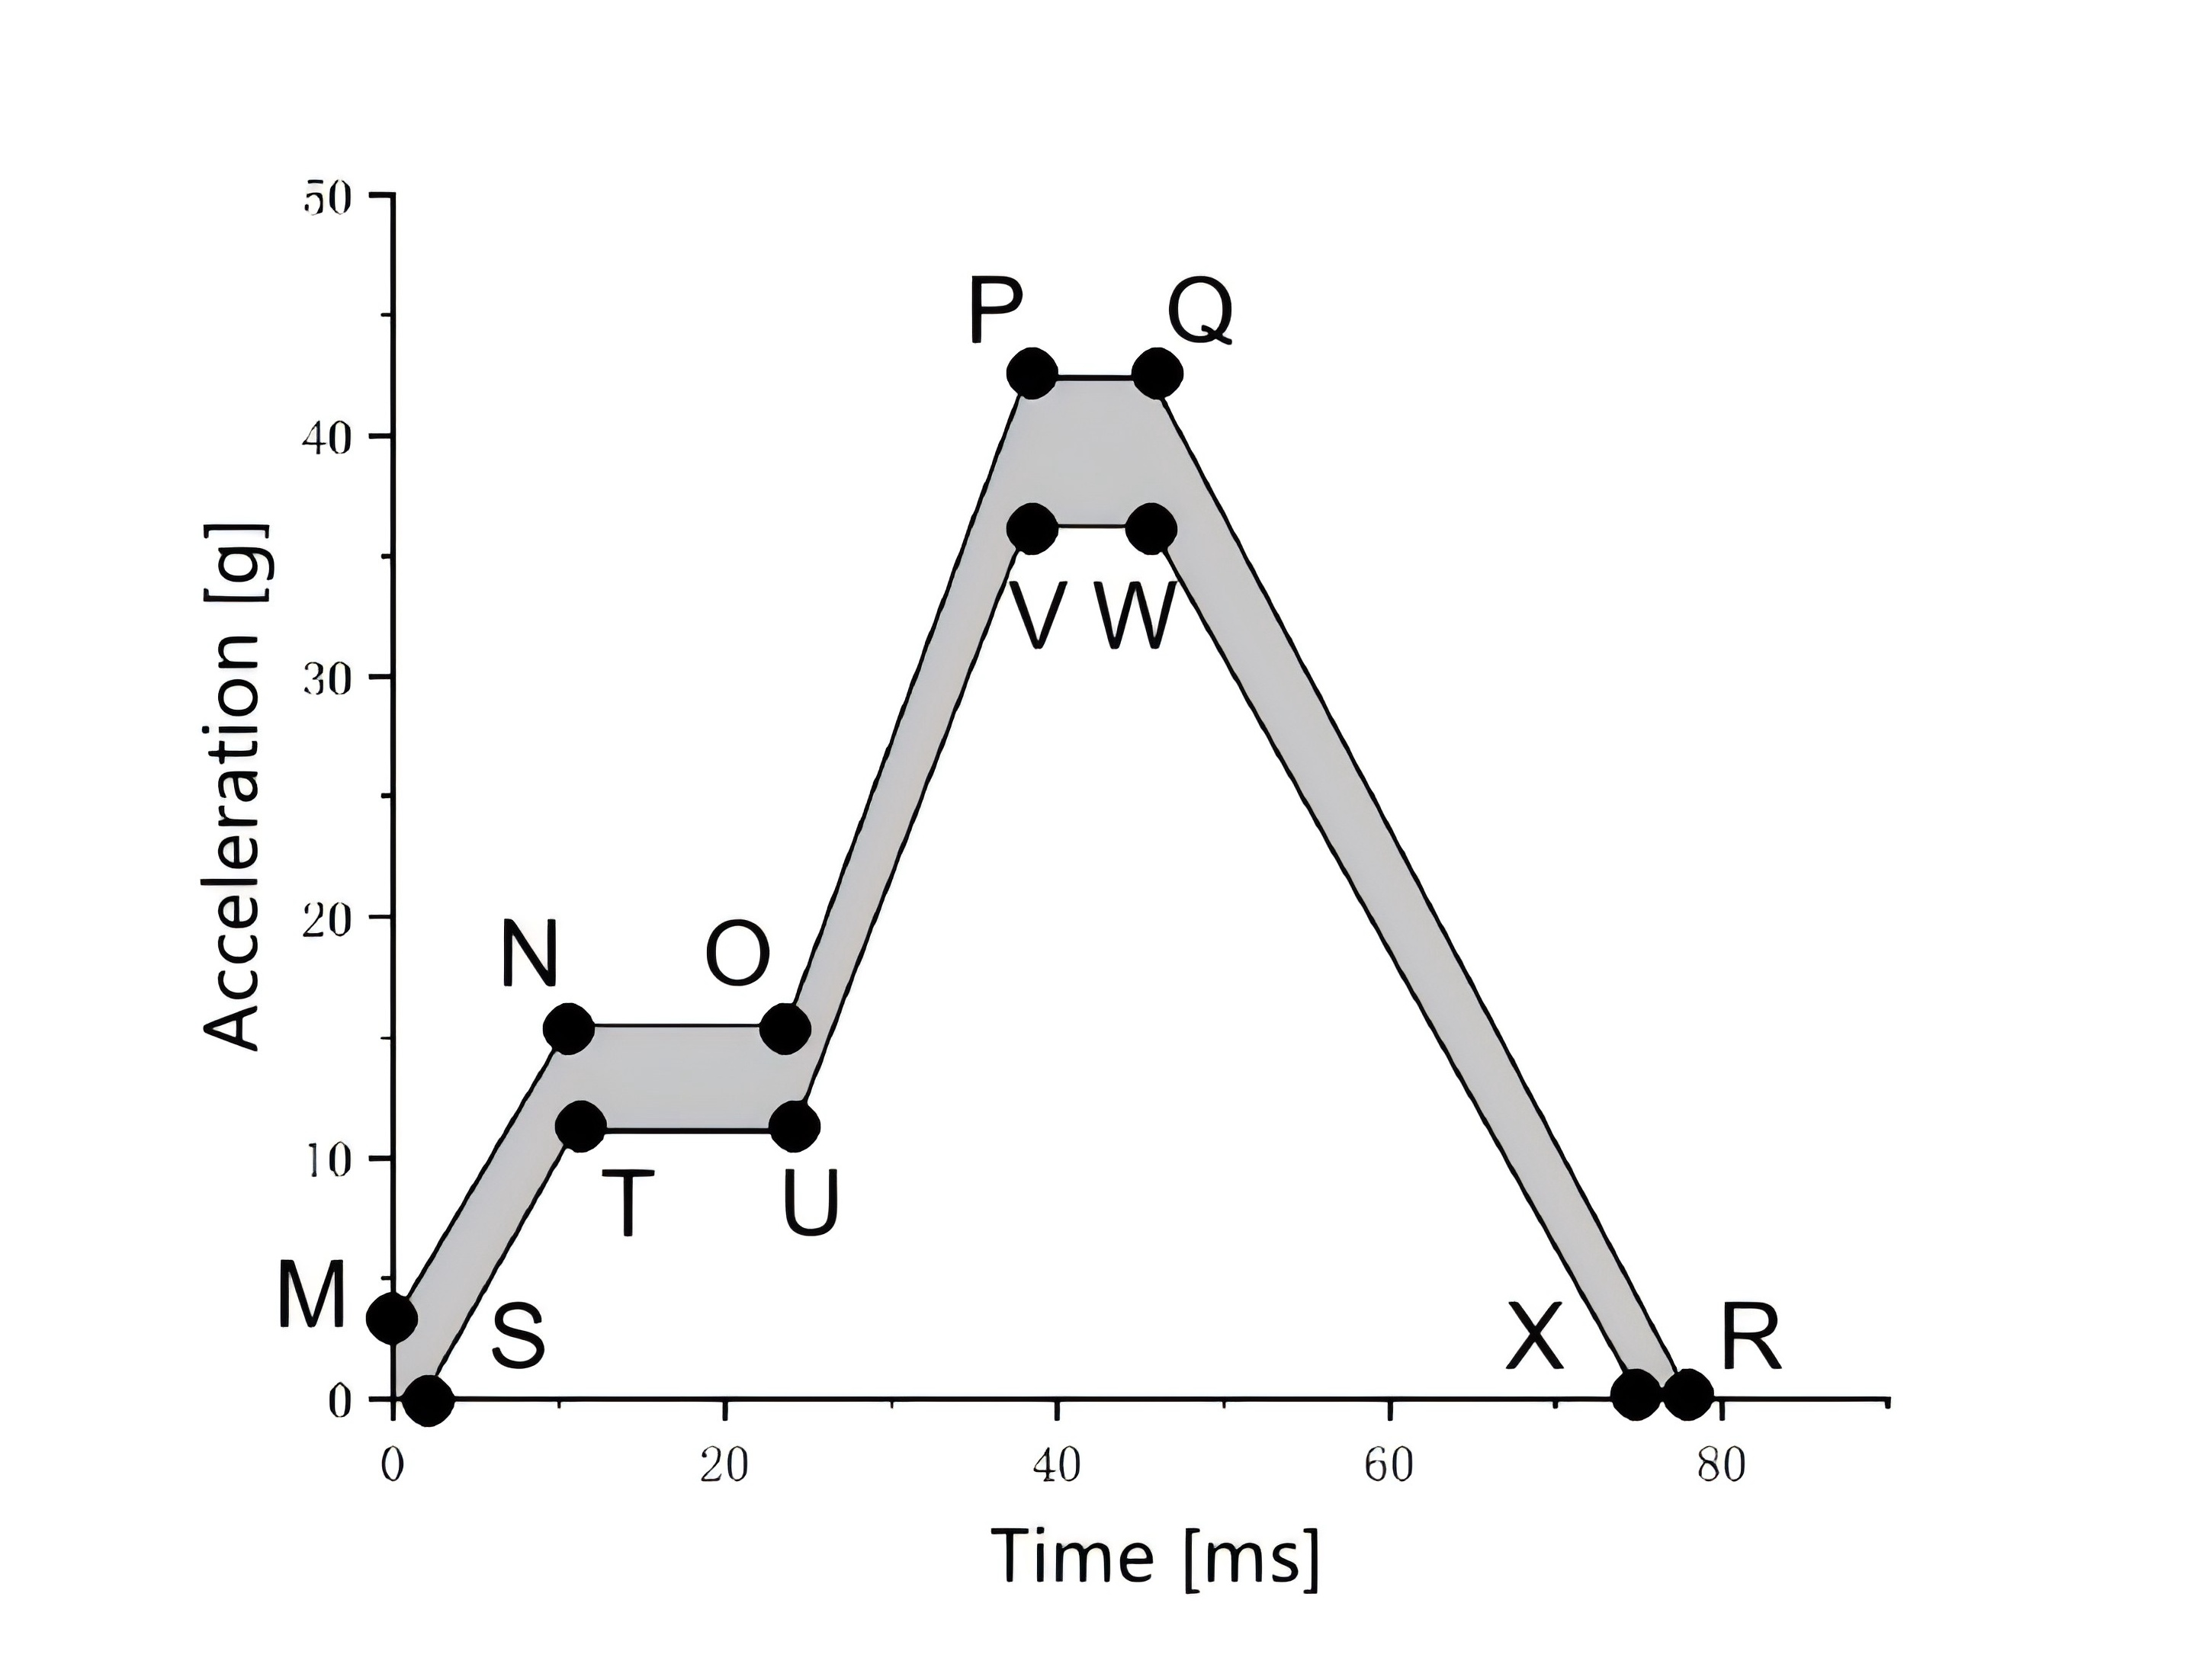
Figure 3 — Sled Deceleration or Acceleration pulse Corridor for FRB Test
Table 2 — Key Point Coordinates for MPDB test pulse Corridor Upper and Lower Bounds
Upper Limit Points | Coordinates  (ms, m/s²) | Lower Limit Points | Coordinates  (ms, m/s²)
A | (0, 3.0) | G | (2.0, 0)
B | (6.6, 13.5) | H | (10.0, 10.7)
C | (23.8, 13.5) | I | (26.0, 10.7)
D | (38.9, 26.5) | J | (39.4, 23.5)
E | (68.2, 26.5) | K | (67.0, 23.5)
F | (95.0, 0) | L | (88.4, 0)

Table 3 — Key Point Coordinates for FRB test pulse Corridor Upper and Lower Bounds
Upper Limit Points | Coordinates  (ms, m/s²) | Lower Limit Points | Coordinates  (ms, m/s²)
M | （0,3.1） | S | （1.8,0）
N | （10.6,15.5） | T | （10.9,11.1）
O | （23.7,15.5） | U | （24.1,11.1）
P | （38.1,42.4） | V | （38.1,36.2）
Q | （45.6,42.4） | W | （45.6,36.2）
R | （78.1,0） | X | （75.1,0）

6.3 Seat Adjustment
Before the test, first determine the test seat target position according to 6.3.2. Next, determine the test seat standard position according to 6.3.3 and measure relevant angles and coordinates at the standard position. Finally, adjust the seat to the target position, confirm it according to 6.3.4, and proceed with dummy placement according to 6.4.
6.3.1 HPM-II Measurement Method
6.3.1.1 If the seat being measured has never been sat in, have a 70 kg – 80 kg person or device sit on it twice for 1 minute each to deform the cushion and backrest foam. Before placing the HPM-II, the seat shall remain unloaded for at least 30 minutes to allow the seat and seat materials (e.g., foam) to recover from compression.
6.3.1.2 Before placing the HPM-II, cover the seat with a smooth, thin cloth (as per GB/T 29120). The cloth shall cover both the backrest and cushion to prevent slipping. If needed, use two cloths (one for the cushion, one for the backrest) to ensure uniform friction between the HPM-II and all seat surfaces.
6.3.1.3 Place the seat pan on the seat, lightly resting its back against the seat backrest, ensuring its center aligns with the seat centerline.
6.3.1.4 To protect the pan and back panel housings, lock them in the relaxed position before installing the back panel. Adjust the back panel to the relaxed position (LSP < 0) and lock. Place the H-point pivot pin at the bottom of the back panel into the H-point pivot pin of the seat pan. The upper part of the back panel should not contact the seat backrest. Secure by sliding the brass locking bushing inward over the H-point pivot pin.
6.3.1.5 Unlock the torso joint. Firmly hold the seat pan's T-bar to maintain its position. Use the other hand to hold the back panel's T-bar, gently rotating the back panel assembly to conform to the seat backrest contour. Ensure the edges of the lumbar part are outside the thoracic and pelvic areas, and the cloth is not caught in the back panel components. (Note: The seat pan and back panel can be connected and installed as a single unit if desired. Follow steps similar to above, centering the seat pan against the backrest, rotating the back panel forward, and locking it in the relaxed position.)
6.3.1.6 Check the level bubble on the seat pan. Rotate and adjust the HPM-II to position it horizontally level on the seat, ensuring close contact with the seat backrest.
6.3.1.7 Pre-adjust the torso angle of the back panel to approximately 2° less than the one-click zero gravity angle. Set the cushion angle of the seat pan slightly higher than the desired angle.
6.3.1.8 Installing weights on the HPM-II is called "loading". The HPM-II shall be loaded with the torso hinge mechanism unlocked. Weights shall be installed starting from the H-point outward and upward, preventing the HPM-II from sliding off the seat. Before each round of weight installation, "punch" the appropriate loading location twice with 89 N of force using a spring-loaded probe. Once the probe reaches its loading load, the operator shall immediately release the applied force. This procedure ensures the HPM-II maintains full contact with the seat during loading.
6.3.1.9 During loading, check that the HPM-II remains level. The operating procedure for loading the HPM-II shall follow Table 4.
Table 4 — HPM-II Loading Operation Procedure
Step | Apply 89N  (Punch twice ) | Install 2 Weight Blocks | Install 2 Weight Blocks (again) |  | Check
1 | Seat Pan | Pelvic  Innermost position |  | Femur | Level
2 | Seat Pan | Pelvic Next-to-outermost position |  | Femur | Level
3 | Seat Pan | Wedge Pelvic  Outermost position |  | Femur | Level
4 | Back Panel | Lower Hanger  Innermost position |  | Upper Hanger  Innermost position | Level
5 | Back Panel | Lower Hanger  Next-to-outermost position |  | Upper Hanger  Next-to-outermost position | Level
6 | Back Panel | Lower Hanger  Outermost position |  | Upper Hanger  Outermost position | Level
7 | Lock torso hinge mechanism
6.3.1.10 Loading the Seat Pan: Two types of weights are used for loading the seat pan: pelvic weights installed in the pelvic weight mounting slots along the H-point pivot pin, and femur weights installed on the femur weight mounting pins. Punch the HPM-II twice at the seat pan load application points. Install two pelvic weights in the innermost pelvic weight mounting slot (one on each side of the H-point). Install two femur weights (one on each side). Check level. Repeat these steps twice to complete seat pan loading.
6.3.1.11 Loading the Back Panel: The back panel has two weight loading areas: the upper hanger and the lower hanger. The same type of weight block is used for both. Punch the HPM-II twice at the back panel load application point. Install two weights on the lower hanger (one on each side of the centerline), pushing them as close to the centerline as possible. Install two weights on the upper hanger (one on each side of the centerline), pushing them towards the centerline. Check level. Repeat these steps twice. After the back panel is loaded and level, lock the torso hinge mechanism.
6.3.1.12 Level the HPM-II so that the deviation of the left and right H-point coordinates is within ±2.5 mm.
6.3.1.13 After installation, wait for 5 minutes before recording data.
6.3.1.14 Recording H-point: The H-point is located on the centerline of the HPM-II. This point cannot be measured directly but is calculated as the average of the measured values from the markers on both sides of the H-point bar.
6.3.1.15 Use a goniometer and the corresponding measurement tool to measure the following: Torso angle on the back panel assembly angle measurement tool, Cushion angle on the cushion angle measurement tool.
6.3.1.16 If the torso angle or cushion angle is outside the design angle ±1° range, disassemble the HPM-II, re-adjust the seat, and place the HPM-II again. Before each HPM-II placement, let the seat rest unloaded for 30 minutes to allow the seat materials to recover.
6.3.2 Seat Target Position Adjustment
6.3.2.1 If the test seat has a one-click zero gravity position, the reclined seat test angle shall be adjusted according to this position. This position is defined as the Seat Target Position (TP). Use the 3-D H-point machine according to 6.3.1 to measure the Torso angle of Target Position (BATP) and Cushion angle of Target Position (CATP). Determine the Seat Center (SC) about which the seat rotates while maintaining a constant Seat Opening Angle (SOA). Also determine another reference point, the Backrest Point (BP), on a harder surface on one edge of the backrest. Use a coordinate measuring machine (CMM) to measure and record the X and Z coordinates of SC and the center of BP, recorded as (XSC, ZSC)_TP and (XBP, ZBP)TP respectively. Record the H-point (XHP, ZHP)TP measured by the HPM-II at the target position.
6.3.2.2 If the automotive reclined seat does not have a one-click zero gravity position, adjust according to the manufacturer's design position. For seats without either a one-click zero gravity position or a specified design position, adjust according to Table 5 for the reclined seat test angle. After seat adjustment, repeat the measurement of torso angle, cushion angle, seat rotation center, and backrest reference point as in 6.3.2.1. If the seat under test is in the second or third row, the position of the corresponding front seat (the one it faces) shall be set according to the linked adjustment position for the one-click zero gravity position as a priority. If no such function exists, the corresponding front seat shall be adjusted to its rearmost and lowest position, with the backrest adjusted to the design angle or 25°. If the dummy's feet interfere with the front seat, adjust the front seat forward until there is just no contact.
Table 5 — Reclined Seat Adjustment Parameters
Item | Adjustment Requirement | Note
Seat Fore/Aft | Middle position | If this position affects backrest adjustment, adjust to the last position that does not affect backrest adjustment.
Seat Height | Middle position | If this position affects backrest adjustment, adjust to the lowest position that does not affect backrest adjustment.
Torso Angle | Maximum angle | Angle from vertical
Cushion Tilt Angle | Minimum angle | Angle from horizontal
Cushion Height | Lowest position
Calf Rest Angle | Middle position
Foot Rest | Deployed | Adjust to use state
Lumbar Support | Fully retracted | Lowest / rearmost position
Headrest Height & Angle | Middle locked position | Adjust near 0° angle of headrest rods
Seat Armrest | Retracted
Other Settings | Retracted

6.3.3 Seat Standard Position Adjustment
6.3.3.1 Maintain constant SOA. Rotate the seat as a whole until the cushion angle measured according to 6.3.1 using the HPM-II is 14.5°. This seat posture is defined as the Seat Standard Position (SP). If the cushion angle cannot be adjusted to 14.5°, adjust it to the closest possible angle. If the seat cannot be rotated as a whole, adjust the cushion and backrest separately, ensuring the measured SOA matches the SOA at the target position.
6.3.3.2 At the seat standard position, use a CMM to measure and record the X and Z coordinates of the seat rotation center and the center of the backrest reference point: (X_{SC}, Z_{SC})_SP and (X_{BP}, Z_{BP})_{SP}.

6.3.4 Final Confirmation of Seat Target Position
6.3.4.1 Maintain constant SOA. Rotate the seat as a whole to the TP. Use a CMM to confirm that the coordinates of the backrest reference point return to (X_{BP}, Z_{BP})_{TP}. Simultaneously, confirm that the cushion angle and torso angle measured using the HPM-II according to 6.3.2.1 return to the test-specific cushion angle CA_{TP} and torso angle BA_{TP}.

6.4 Dummy Adjustment and Positioning
Position the dummy before the test. After dummy positioning and measurement, minimize vehicle movement or shaking until the test begins. If the test is interrupted unexpectedly, the dummy positioning and measurement procedures shall be repeated.

6.4.1 Determining Target Position H-point Coordinates and Pelvis Angle
6.4.1.1 Round the torso angle BA_{SP} at the cushion standard position and use Table 6 to find the reference pelvis angle PA_{SP} at the standard position.
6.4.1.2 Based on the recorded coordinates (X_{SC}, Z_{SC})_{TP}, (X_{BP}, Z_{BP})_{TP}, and (X_{BP}, Z_{BP})_{SP}, calculate the pelvis angle difference Angle_{D} from the seat target position to the standard position.
$${Angle}_{D}=arccos(\frac{{(X}_{BPTP}−X_{SCTP})∙{(X}_{BPSP}−X_{SCTP})+{(Z}_{BPTP}−Z_{SCTP})∙{(Z}_{BPSP}−Z_{SCTP})}{\sqrt{{{(X}_{BPTP}−X_{SCTP})}^{2}+{{(Z}_{BPTP}−Z_{SCTP})}^{2}}∙\sqrt{{{(X}_{BPSP}−X_{SCTP})}^{2}+{{(Z}_{BPSP}−Z_{SCTP})}^{2}}})（1）$$
6.4.1.3 Calculate the reference pelvis angle PA_{TP} at the target position using PA_{SP} and Angle_{D}: PA_{TP} = PA_{SP} + Angle_{D}.
Table 6 — BA_{SP} to PA_{SP} Correspondence
Measured Parameter | Value (Degrees)
BA_{SP} | 21 | 22 | 23 | 24 | 25 | 26 | 27 | 28 | 29 | 30
PA_{SP} | 57.5 | 57.8 | 58.1 | 58.5 | 58.8 | 59.1 | 59.5 | 59.8 | 60.1 | 60.5
BA_{SP} | 31 | 32 | 33 | 34 | 35 | 36 | 37 | 38 | 39 | 40
PA_{SP} | 60.8 | 61.1 | 61.5 | 61.8 | 62.1 | 62.4 | 62.8 | 63.1 | 63.4 | 63.8
BA_{SP} | 41 | 42 | 43 | 44 | 45 | 46 | 47 | 48 | 49 | 50
PA_{SP} | 64.1 | 64.4 | 64.8 | 65.1 | 65.4 | 65.8 | 66.1 | 66.4 | 66.8 | 67.1
BA_{SP} | 51 | 52 | 53 | 54 | 55 | 56 | 57 | 58 | 59 | 60
PA_{SP} | 67.4 | 67.7 | 68.1 | 68.4 | 68.7 | 69.1 | 69.4 | 69.7 | 70.1 | 70.4
BA_{SP} | 61 | 62 | 63 | 64 | 65 | 66 | 67 | 68 | 69 | 70
PA_{SP} | 70.7 | 71.1 | 71.4 | 71.7 | 72.0 | 72.4 | 72.7 | 73.0 | 73.4 | 73.7
6.4.1.4 Calculate the modified THOR dummy target pelvis angle PA_{DTP} from the target position reference pelvis angle PA_{TP}:
$$\begin{aligned}{PA}_{DTP}={PA}_{TP}−{20}^{°}\#\left(2\right)\end{aligned}$$
6.4.1.5 Calculate the modified THOR dummy target H-point X and Z coordinates (X_{dummy}, Z_{dummy}) from the target position HPM-II H-point coordinates (X_{HP}, Z_{HP})_{TP}:
$$\begin{aligned}X_{dummy}=X_{HP}−13mm\#（3）\end{aligned}$$
$$\begin{aligned}Z_{dummy}=Z_{HP}+21mm\#（4）\end{aligned}$$

6.4.2 Adjustment of Other Dummy Parts

6.4.2.1 Torso
6.4.2.1.1 Place the dummy symmetrically on the seat cushion. The back shall contact the seat backrest. The dummy's midsagittal plane shall be vertical and pass through the center of the cushion.
6.4.2.1.2 Use the dummy's built-in tilt sensors to confirm its position, ensuring the line passing through the dummy's hip pivot center is perpendicular to the seat's center XZ-plane.

6.4.2.2 Arm
The upper arms shall be as close as possible to the torso, with elbows contacting the seat backrest, left and right symmetrical.

6.4.2.3 Hands
Place hands on the thighs, palms facing down towards the thighs, middle fingers aligned with the line connecting the knee to the thigh screw hole. If the test seat has an armrest that is adjustable, rotate the armrest upwards to be flush with the backrest. If the armrest is non-adjustable, remove it for the test.

6.4.2.4 Hands
6.4.2.4.1 Use the dummy's built-in tilt sensors to confirm the head angle. The angle around the X-axis shall be 0° ± 1°. The angle around the Y-axis is not specified.
6.4.2.4.2 No Contact Condition: If the head does not contact the head restraint, adjust the backrest within ±1° of the design or specified angle so that the head restraint contacts the head. If contact is still not achieved, and the head restraint is adjustable in the X-direction, adjust it forward until contact is made. If contact remains impossible and no further adjustment is possible, continue with the test and document the condition.

6.4.2.5 Legs and Feet
The dummy's thighs and lower legs shall be in contact with the cushion and leg support, respectively. The distance between the outer surfaces of the knee U-flanges shall be within 270 mm ± 10 mm. Place the thighs on the cushion and lower legs on the calf rest. If the front seat is designed with a foot rest for the reclined seat occupant, rotate the foot rest to a position where the dummy's feet rest naturally on it. Place both feet parallel on the foot rest. If no foot rest is present, let the feet hang naturally.

6.4.2.6 H-point
6.4.2.6.1 The dummy's "H-point" shall be within 13 mm vertically and 13 mm horizontally of the point defined by the HPM-II H-point determined in 5.4.1.5, shifted 20 mm upward and 20 mm forward. Fine adjustments to the dummy's pelvis position on the cushion (by gently pushing on the knees or pulling on the thighs to move the pelvis forward/backward) can be made to meet the requirement.
$$\begin{aligned}X_{dummy}=X_{HP}−13mm±13mm\#（5）\end{aligned}$$
$$\begin{aligned}Z_{dummy}=Z_{HP}+21mm±13mm\#（6）\end{aligned}$$
6.4.2.6.2 If the dummy's H-point is not within the target value range, start readjustment from 5.4.2.1. If the requirement cannot be met, adjust to the closest possible position.

6.4.2.7 Pelvis Angle
6.4.2.7.1 Use the dummy's built-in pelvis tilt sensor to confirm the pelvis angle is within 0° ± 1° (around X-axis).
6.4.2.7.2 Use the dummy's built-in pelvis tilt sensor to confirm the pelvis angle is within PA_{DTP} ± 2.5° (around Y-axis), where PA_{DTP} is specified in 6.4.1.4.

6.4.2.8 Others
If the dummy positioning cannot simultaneously meet the requirements of 6.4.2.6 and 6.4.2.7, fine-tune the dummy prioritizing the H-point position range, then select the position closest to the target pelvis angle

6.4.2.9 Seat Belts
Fasten the seat belt and remove slack. Pull out the shoulder belt and let it retract naturally. Repeat 4 times.

6.5 High-Speed Video

6.5.1 Test Photography
Record the state of the reclined seat and dummy before and after the collision test, as well as the dummy's posture before/after the test, the relative position of the dummy's neck and seat belt webbing, etc., as per Table 7.
Table 7 — Test Photo Position Requirements
No. | Photo Position | Before Test |  | After Test
1 | Seat backrest angle | √ | /
2 | Seat cushion angle | √ | /
3 | Leg rest angle | √ | /
4 | Slide Rail Angle | √ | /
5 | Dummy positioning posture angle | √ | /
6 | Left-side overall view | √ | √
7 | 45° front-left view | √ | √
8 | Front overall view | √ | √
9 | 45° front-right view | √ | √
10 | Right-side overall view | √ | √
11 | Left side of dummy and seat | √ | √
12 | 45° left-front view of dummy | √ | √
13 | Front view of dummy and seat | √ | √
14 | 45° right-front view of dummy | √ | √
15 | Right side of dummy and seat | √ | √
16 | Left side of dummy and seat | √ | √
17 | Dummy lower legs | √ | √
18 | Seat installation position | √ | √
19 | Neck-to-belt webbing contact | √ | √
20 | Upper belt anchorage | √ | √
21 | Lower belt anchorage | √ | √
22 | Belt buckle | √ | √
23 | Retractor and webbing exit | √ | √
24 | Airbag contact area | / | √
25 | Seat abnormal state | / | √

6.5.2 High-Speed Video Recording
Use at least 3 on-board high-speed cameras for the test. At least one high-speed camera shall be placed at each of the positions numbered 1, 2, 3, and 4 in Table 8. The frame rate shall be no less than 1000 frames per second. The minimum camera resolution shall be 1280 x 1024. Recording time shall be from -20 ms to 300 ms relative to impact. Figures 4a and 4b show examples of on-board high-speed camera positions relative to the reclined seat when the seat is in the front row vs. rear row, and when using a body-in-white vs. fixture. Table 8 lists the shooting angles for on-board high-speed cameras.

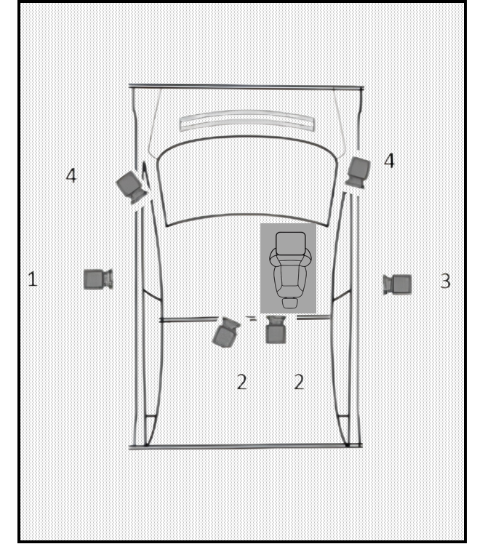
Figure 4a — On-board High-Speed Cameras - Position (Front Row Reclined Seat, Body-in-white fixed to sled
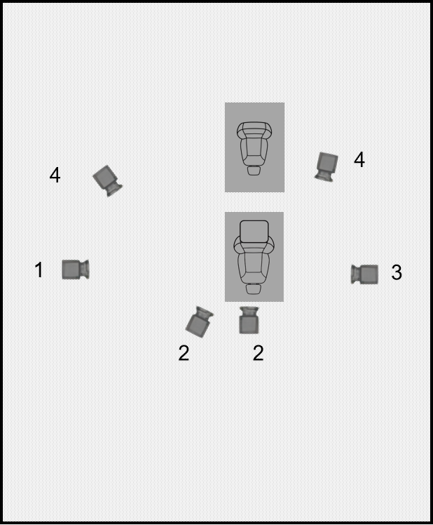
Figure 4b — On-board High-Speed Cameras - Position (Rear Row Reclined Seat, Front Row Standard Seat, Fixture fixed to sled
Table 8 — On-board High-Speed Camera Angles
No. | Perspective | Description
1 | Left-side overall | Left side dummy motion and seat movement
2 | Rear view | Frontal airbag deployment and dummy/airbag interaction
3 | Right-side overall | Right side dummy and seat motion process
4 | Upper-side view | Dummy and seat motion process from upper side
All instrument measurements shall follow the sign convention shown in Figure 5. The +X direction points forward relative to the dummy. The +Y direction points to the right relative to the dummy. The +Z direction points downward (Note: Detailed information on the measurement sign convention can be obtained from SAE, refer to SAE J 1733-2007 Sign Convention for Vehicle Crash Testing). All test instruments shall be within their valid calibration period.
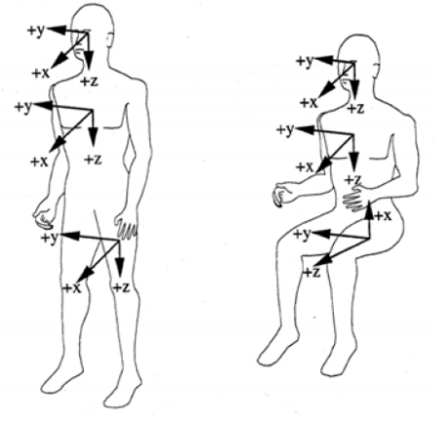
Figure 5 — Dummy Coordinate System

6.6 Data Acquisition and Processing

6.6.1 Vehicle Test Instrumentation
6.6.1.1 Install an accelerometer horizontally in the X-direction at the B-pillar base (rocker panel) location. Its installation shall not affect the normal function of the seat belt retractor / pretensioner.
6.6.1.2 The shoulder belt tension sensor weight shall be less than 100 g. Its calibration procedure shall comply with ISO/TS 17242:2014. If the installation of the shoulder belt tension sensor significantly affects the natural fit of the seat belt, auxiliary tools such as tape may be used to mitigate this.
6.6.1.3 For seats equipped with a pretensioner, ensure sufficient distance between the shoulder belt tension sensor mounting position and the D-ring to prevent interference during belt pretensioning.

6.6.2 Measurement Parameters and Channel Requirements for Dummy, Sled, Belt and Body-in-white
See Table 9.
Table 9 — Measurement Parameters and Channel Requirements
Measurement Location | Parameters | Channels
Head | Acceleration (Ax, Ay, Az) | 3
Head | Angular velocity (ωx, ωy, ωz) | 3
Head | Inclination (X, Y) | 2
Upper Neck | Forces (Fx, Fy, Fz) | 3
Upper Neck | Moments (Mx, My, Mz) | 3
Neck | Inclination (X, Y) | 2
T1 Vertebra | Acceleration (Ax, Ay, Az) | 3
T4 Vertebra | Acceleration (Ax, Ay, Az) | 3
Clavicles (L&R) | Force | 8
Thorax | Compression (DC0) | 4
Thorax | Angles (Y, Z) | 8
Thorax | Inclination (X, Y) | 2
Thorax | Acceleration (Ax, Ay, Az) | 1
Sternum | Acceleration (Ax) | 1
Abdomen | Pressure (P) | 2
T12 Vertebra | Acceleration (Ax, Ay, Az) | 3
T12 Vertebra | Forces (Fx, Fy, Fz) | 3
T12 Vertebra | Moments (Mx, My, Mz) | 3
Lumbar | Inclination (X, Y) | 2
Pelvis | Acceleration (Ax, Ay, Az) | 3
Pelvis | Angular velocity (ωy) | 1
Pelvis | Inclination (X, Y) | 2
Ilium (L&R) | Force (Fx) | 4
Acetabulum (L&R) | Forces (Fx, Fy, Fz) | 6
Femur (L&R) | Forces (Fx, Fy, Fz) | 6
Femur (L&R) | Bending moments (Mx, My, Mz) | 6
Knee (L&R) | Displacement (D) | 2
Upper Tibia (L&R) | Forces (Fx, Fz) | 4
Upper Tibia (L&R) | Moments (Mx, My) | 4
Lower Tibia (L&R) | Forces (Fx, Fz) | 4
Lower Tibia (L&R) | Moments (Mx, My) | 4
Foot (L&R) | Acceleration (Ax, Ay, Az) | 6
Sled | Acceleration Ax | 2
Belt | Shoulder Belt Force F | 1
Belt | Lap Belt Force F (Both Sides) | 2
Body-in-white | Acceleration at Both B-pillars Sills Ax | 2

6.6.3 The requirements for measurement parameters and filter classes for the dummy and sled are shown in Table 10.
Table 10 — Dummy and Sled Measurement Parameters and Filter Classes
Measurement Location | Parameters | Filter Class
Head | Acceleration (Ax, Ay, Az) | CFC 1000
Head | Angular velocity (ωx, ωy, ωz) | CFC 60
Upper Neck | Forces(Fx, Fy, Fz) | CFC 1000
Upper Neck | Moment (Mx, My, Mz) | CFC 600
T1/T4 Vertebra | Acceleration (Ax, Ay, Az) | CFC 1000
Clavicles | Force | CFC 600
Thorax | Compression (DC0) | CFC 180
Thorax | Acceleration (Ax, Ay, Az) | CFC 1000
Sternum | Acceleration Ax | CFC 1000
Abdomen | Pressure (P) | CFC 180
T12 Vertebra | Acceleration (Ax, Ay, Az) | CFC 1000
T12 Vertebra | Force/ Moment | CFC 600
Pelvis | Acceleration (Ax, Ay, Az) | CFC 1000
Pelvis | Angular velocity (ωy) | CFC 180
Ilium/ Acetabulum | Force/ Moment | CFC 600
Knee | Displacement | CFC 180
Femur/ Tibia | Force/ Moment | CFC 600
Foot | Acceleration (Ax, Ay, Az) | CFC 180
Sled/Body-in-White | Acceleration | CFC 60
Belt | Belt force | CFC 60

6.6.4 Total Test Channels
See table 11.
Table 11 — Test Channel Summary
Measurement System | Channels
Sled channels | 7
Dummy channels | 111
Total Channels | 118

- Active Safety Test Methods

7.1 Vehicle Preparation
7.1.1 The vehicle shall be new, with a mileage not exceeding 5000 km.
7.1.2 The vehicle condition shall be checked. Any abnormality shall be recorded and rectified, or the vehicle shall be replaced.
7.1.3 The OEMs shall provide documentation describing the deactivation function, the warning function, and the emergency retract function of the vehicle reclined seat.
7.1.4 For Internal Combustion Engine (ICE) vehicles, the fuel level shall be at least 50% of the tank capacity before testing. For Battery Electric Vehicle (BEV) and Plug-in Hybrid Electric Vehicle (PHEV), the traction battery shall be fully charged before testing. For non-externally chargeable New Engergy Vehicle (NEV), the vehicle shall be prepared in the normal vehicle operating state.
7.1.5 Other vehicle fluids (e.g., coolant, brake fluid, engine oil) shall be checked and ensured to reach at least the minimum indicated level. If no minimum mark is provided, they shall be filled to the full level.

7.2 Test Conditions

7.2.1 Test Track
The test track shall meet the following requirements:
a) The lane shall be flat, no significant potholes, cracks or other defects, with a maximum longitudinal slope of ±1%;
b) The test surface shall be dry, no visible moisture and paved by asphalt or concrete , the test surface shall have a minimal peak braking coefficient of 0.8.

7.2.2 Weather Conditions
The test environment shall meet the following requirements:
a) The illuminance of daylight tests shall be greater than 2 000 lux;
b) The ambient temperature shall be between 0 °C and 45 °C, and the wind speed shall not exceed 5 m/s.

7.2.3 Test Equipment
The frame rate of the camera equipment is ≥25 fps, and at least two camera devices shall be used during the test.

7.3 Test Methods

7.3.1 Deactivation Function Test
After the vehicle is started and all doors are closed, the test personnel shall be seated in the test seat, correctly fasten the seat belt, and adjust the seat to the zero gravity position.
The transmission shall be shifted to the forward gear and the accelerator pedal depressed. The vehicle state, speed, driving distance, and seat state changes shall be recorded.

7.3.2 Warning Function Test
After the vehicle is started and all doors are closed, the test personnel shall be seated in the test seat, correctly fasten the seat belt, and adjust the seat to the zero gravity position.
The transmission shall be shifted to the forward gear. According to the trigger requirements of the warning function, accelerate the vehicle to ${25}_{ 0}^{+2}$km/h or drive it under the normal operating state for ${500}_{ 0}^{+10}$m until the visual and audible warning signals are triggered. Record the trigger time, as well as the vehicle speed or driving distance at the moment of triggering.

7.3.3 Emergency Retract Function Test
The test parameters are shown in Table 12 and Figure 6.
Table 12 — CCRs scenario parameters
Subject vehicle speed (km/h) | Target vehicle speed (km/h) | Test start distance (m) | Target type | Lighting condition | Overlap rate | Number of tests
50 | 0 | 60 | Sedan | Daylight | 100%; ±50%; ±25% | 3
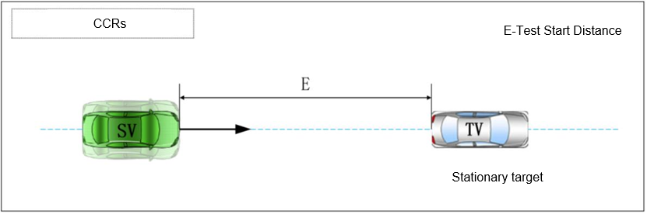
Figure 6 — Stationary target vehicle scenario

7.3.3.1 Test procedure
a) One overlap rate shall be randomly selected. The target vehicle shall be stationary and positioned in front of the subject vehicle. The centre axis of the target vehicle shall align with the direction of travel of the subject vehicle;
b) The rear center point of the target vehicle shall be used as the reference impact point. The impact point shall be the same for each test. Record the longitudinal and lateral relative positions of the two vehicles;
c) The AEB braking function of the subject vehicle shall be deactivated. The subject vehicle shall then be accelerated to 50 km/h. When the distance between the subject vehicle and the target vehicle reaches 60 m, the test shall be officially begun and the emergency retract motion of the vehicle reclined seat shall be recorded;
d) The test shall end when the subject vehicle impacts the target vehicle.

7.3.3.2 Test requirements
a) The speed shall remain stable. After the test begins, the subject vehicle speed shall be maintained at (50 ± 1) km/h;
b) After the test begins, the steering wheel angular speed of the subject vehicle shall not exceed 15°/s, and the lateral distance between the two vehicles shall not exceed ±0.2 m;
c) The subject vehicle shall not apply the brake pedal, perform sudden braking or steering before the test ends. After the test begins, the yaw rate of the subject vehicle shall not exceed ±1.0°/s;
d) After the test begins, the accelerator pedal position fluctuation shall not exceed ±5% of the full scale.

7.3.4 Anti-pinch Function Test

7.3.4.1 Static test

After the vehicle is started and all doors are closed, the test personnel on the seat to be tested and the adjacent seat with their seat belts unfastened. Adjust the tested seat to the zero gravity position (by voice commands or physical button), and the seat state changes shall be recorded. The occupants in the seat to be tested using Q3 and Q1.5 dummies and each adjacent seat of the seat to be tested shall be occupied by one 5th percentile occupant.

7.3.4.2 Dynamic test
After the vehicle is started and all doors are closed, the seat to be tested shall be occupied by an adult occupant. If the adjacent seat allows child occupancy, tests shall be conducted separately using Q3 and Q1.5 dummies together with a CRS. The test personnel shall shift the transmission to the forward gear, depress the accelerator pedal and drive at idle speed. Adjust the tested seat to the zero gravity position (by voice commands or physical button), and the seat state changes shall be recorded.

Annex A Calculation Methods for Dummy Injury Criteria Technical Requirements

A.1 Head Performance Criterion
Calculate Head Resultant Acceleration AR:
$$\begin{aligned}A_{R}=\sqrt{A_{x}^{2}+A_{y}^{2}+A_{z}^{2}}\#（A.1）\end{aligned}$$
Calculate Head HIC15:
$$\begin{aligned}{HIC}_{15}=\left(t_{2}−t_{1}\right){\left[\frac{\int_{t_{1}}^{t_{2}}{A_{R}.dt}}{\left(t_{2}−t_{1}\right)}\right]}^{2.5}\#（A.2）\end{aligned}$$
Where A_x, A_y, A_z are the measured values from the head triaxial accelerometers, in units of g.
If the head contact initiation time can be determined, then t2 and t1 are two times (in seconds) within the period from the start of head contact to the end of recording, representing the interval where HIC is maximum. If head contact initiation time cannot be determined, then t2 and t1 are two times (in seconds) within the period from the start to the end of recording, representing the interval where HIC is maximum. t2 - t1 ≤ 15 ms.

A.2 Neck Performance Criteria
Calculate Neck Shear Force Fx and Tension Force Fz:
$$\begin{aligned}Fx=max\left(Fx\left(t\right)\right)\#（A.3）\end{aligned}$$
$$\begin{aligned}Fz=max\left(Fz\left(t\right)\right)\#（A.4）\end{aligned}$$
Fx is the measured shear force from the upper neck X-direction force sensor. Fz is the measured tension force from the upper neck Z-direction force sensor. Units: kN.
If the test dummy is the THOR-AV 50M or a dummy with an identical neck structure, calculate the Neck Extension Moment Mocy:
$$\begin{aligned}M_{ocy}=M_{y}\left(t\right)−F_{x}\left(t\right)∗d\#（A.5）\end{aligned}$$
Where My is the measured extension moment from the upper neck Y-direction moment sensor (N·m), Fx is the measured value from the upper neck X-direction force sensor (N), and d = 0.03005 m.
If the test dummy is the THOR 50M, THOR-RS 50M, or a dummy with an identical neck structure, calculate the Neck Extension Moment Mocy:
$$\begin{aligned}M_{ocy}=M_{y}\left(t\right)\#（A.6）\end{aligned}$$

A.3 Abdomen Performance Criterion
Calculate Abdomen Pressure Criterion P:
$$\begin{aligned}P=max\left(P_{aL}\left(t\right)，P_{aR}\left(t\right)\right)\#（A.7）\end{aligned}$$
Where P_{aL}(t) is the measured value from the left abdomen pressure sensor, P_{aR}(t) is the measured value from the right abdomen pressure sensor. Unit: bar.

A.4 Abdomen Performance Criterion
A.4.1 The Femur Compression Force Fz is evaluated using a cumulative curve. Based on the femur compression force time-history curve, a cumulative curve is derived. The technical requirement is then assessed based on the cumulative curve shown in Figure 1.
A.4.2 Calculate the Pelvis Acetabulum Resultant Compression Force Criterion F(t)_{[L/R]AR}:
$$\begin{aligned}{F\left(t\right)}_{\left[\frac{L}{R}\right]AR}=TW\left(t\right)∗\sqrt{{{F\left(t\right)}^{2}}_{\left[\frac{L}{R}\right]x}+{{F\left(t\right)}^{2}}_{\left[\frac{L}{R}\right]y}+{{F\left(t\right)}^{2}}_{\left[\frac{L}{R}\right]z}}\#（A.8）\end{aligned}$$
Where F(t)_{[L/R]AR} is the resultant force on the left/right hip joint (kN).
F(t)_{[L/R]x}, F(t)_{[L/R]y}, F(t)_{[L/R]z} are the measured values from the left/right acetabulum force sensors (kN).
TW(t) is a piecewise function. For the left hip joint: IF Fx > 0, TW(t)=1; IF Fx ≤ 0, TW(t)=0. For the right hip joint: IF Fx < 0, TW(t)=1; IF Fx ≥ 0, TW(t)=0.
A.4.3 Calculate the Pelvis Ilium Compression Force Criterion:
$$\begin{aligned}F_{x}=\max\left\{\left(F_{{LU}_{X}}\left(t\right)+F_{{LL}_{X}}\left(t\right)\right),\left(F_{{RU}_{X}}\left(t\right)+F_{{RL}_{X}}\left(t\right)\right)\right\}\#\left(A.9\right)\end{aligned}$$
Where F_{LUx}(t), F_{LLx}(t), F_{RUx}(t), F_{RLx}(t) are the measured compression forces from the left upper, left lower, right upper, and right lower ilium force sensors. Unit: kN.

A.5 Spine Performance Criterion
Calculate Lumbar Spine T12 Compression Force Criterion Fz:
$$\begin{aligned}Fz=max\left(Fz\left(t\right)\right)\#（A.10）\end{aligned}$$
Where Fz(t) is the measured compression force from the T12 Z-direction force sensor. Unit: kN.

A.6 Abdomen Performance Criterion
Includes upper/lower tibia axial compression force Fz, knee sliding displacement D, and tibia index TI.
A.6.1 Calculate Knee Sliding Displacement Criterion D:
$$\begin{aligned}D=max\left(D\left(t\right)\right)\#（A.11）\end{aligned}$$
Where D(t) is the measured value from the knee sliding displacement sensor. Unit: mm.
A.6.2 Calculate the Tibia Index TI using the adjusted resultant moment M_Res:
$$\begin{aligned}M_{Res}\left(t\right)=\sqrt{{M_{x}\left(t\right)}^{2}+{M_{y}\left(t\right)}^{2}}\#（A.12）\end{aligned}$$
$$\begin{aligned}TI=max\left(\left|\frac{M_{Res}\left(t\right)}{{\left(M_{C}\right)}_{R}}\right|+\left|\frac{F_{Z}\left(t\right)}{{\left(F_{C}\right)}_{z}}\right|\right)\#（A.13）\end{aligned}$$
Where M_{X}(t) is the measured value from the tibia X-direction moment sensor (N·m), M_{y}(t) is from the Y-direction moment sensor (N·m). (M_{C})_{R} is the critical moment, taken as 240 N·m. F_{Z}(t) is the measured value from the tibia Z-direction force sensor (kN). (F_{C})_{Z} is the critical compression force in Z-direction, taken as 12 kN.
A.6.3 Calculate Tibia Axial Force Criterion Fz:
$$\begin{aligned}Fz=max\left(Fz\left(t\right)\right)\#（A.14）\end{aligned}$$
Where Fz(t) is the measured value from the tibia Z-direction force sensor. Unit: kN.
A.6.4 Calculate Foot Maximum Resultant Acceleration Criterion a:
$$\begin{aligned}a=max\left(\sqrt{A_{Lx}^{2}\left(t\right)+A_{Lz}^{2}\left(t\right)}·\sqrt{A_{Rx}^{2}\left(t\right)+A_{Rz}^{2}\left(t\right)}\right)\#（A.15）\end{aligned}$$
Where A_{Lx}(t), A_{Lz}(t) are the measured values from the left foot accelerometers (X and Z directions), A_{Rx}(t), A_{Rz}(t) are from the right foot accelerometers (X and Z directions). Unit: g.

